**SCHEMA VALIDATOR AND VISUALIZER**

*A project report submitted in partial fulfillment for the award of degree*

# BACHELOR OF TECHNOLOGY

***In***

# ARTIFICIAL INTELLIGENCE & MACHINE LEARNING

***Submitted***

***by***

## KONNI PAVITRA (21MT1A6123)

## GAVIDI KEERTHIKA (21MT1A6113)

## GUDLA VAISHNAVI (21MT1A6115)

## KOSTU THANUJA (21MT1A6126)

## 

**Under the esteemed guidance of**

**Prof. S S R M RAJU PAIDI(Ph.D)**

## Associate Professor

**DEPARTMENT OF ARTIFICIAL INTELLIGENCE & MACHINE LEARNING**

**SRI VENKATESWARA COLLEGE OF ENGINEERING & TECHNOLOGY**

**ISO 9001:2015 certified**

**(Approved by AICTE, New Delhi, Accredited with Grade “B++” by NAAC)**

**(Affiliated to JNTUG Vizianagaram)**

**NH-16, Etcherla-532410, Srikakulam(dist.) Andhra Pradesh**

**2021-2025**

# SRI VENKATESWARA COLLEGE OF ENGINEERING AND

**TECHNOLOGY**

## ETCHERLA-532410 A.P (INDIA)



**DEPARTMENT OF ARTIFICIAL INTELLIGENCE & MACHINE LEARNING**

**BONAFIDE CERTIFICATE**

This is to certify that the Thesis/Dissertation work B.Tech entitled “**SCHEMA VALIDATOR AND VISUALIZER”** is being submitted by **KONNI PAVITRA (21MT1A6123) GAVIDI KEERTHIKA (21MT1A6113) GUDLA VAISHNAVI (21MT1A6115) KOSTU THANUJA (21MT1A6126)** **in** partial fulfillment for the award of the Degree of Bachelor of Technology in **ARTIFICIAL INTELLIGENCE & MACHINE LEARNING during** **2021-2025** is a record of Bonafide work carried out under the guidance and supervision of Prof. **S S R M RAJU PAIDI(Ph.D.**) **Associate Professor & HOD, Department of Artificial Intelligence and Machine Learning**. The result embodied in this project report has not been submitted to any other university or institute for the award of any degree.

This is to certify that the above statement made by the candidate is true and correct to the best of my knowledge.

**Project Guide Head of Department**

**Prof. S S R M RAJU PAIDI (Ph.D,) Prof. S S R M RAJU PAIDI (Ph.D,)**

**Associate Professor Associate Professor**

**Dept of AI&ML Dept of AI&ML**

***EXTERNAL EXAMINER***

Submitted for Viva-voce Examination held on ________________________________

**I**

# DECLARATION

I hereby declare that the dissertation entitled **“SCHEMA VALIDATOR AND VISUALIZER” submitted** for the B. Tech Degree is my own work and the dissertation has not formed the basis for the award of any degree, associateship, fellowship or any other similar titles.

K. Pavitra (Team Lead) – 21MT1A6123

G. Keerthika – 21MT1A6113

G. Vaishnavi – 21MT1A6115

K. Thanuja – 21MT1A6126

**Place: Etcherla**

**Date:**

**II**

# ACKNOWLEDGMENT

We take this opportunity to express our deepest and sincere gratitude to **Dr. B. SRIRAM MURTHY, Director, Dr.B.V.S.N MURTHY and Mr. I. KISHORE, Director VIKAS Educational Society**, for providing all facilities and support to meet our project requirements. We would like to take this opportunity to thank our beloved Principal **Dr. S. C. V. RAMANA MURHTY NAIDU, M. Tech, Ph.D.** for his great support during our project period.

We would like to take this opportunity to thank our Head of the Department of AI & ML Prof. **S S R M RAJU PAIDI (Ph.D)** for his great support during our project period.

It gives us an immense pleasure to express sense of gratitude to our guide **Prof.S S R M RAJU PAIDI (Ph.D), Associate Professor** for his whole hearted and valuable guidance throughout the project. Without him sustained and sincere effort, this project would not have taken this shape. He encouraged and helped us to overcome various difficulties that we have faced at various stages of our project. We would like to sincerely thank for providing all the necessary facilities that leads to the successful completion of our project.

We would like to thank all the faculty members of AI&ML department for their direct and indirect support in helping us for the completion of our project. Also, we would like to thank all our lab technicians of AI & ML department for their valuable suggestions and providing facilities in completion of our project work.

My Family Members and Friends receive my deepest gratitude and love for their support throughout my academic years. Finally, I am thankful to one and all who contributed to my work directly or indirectly.

K. Pavitra (Team Lead) – 21MT1A6123

G. Keerthika – 21MT1A6113

G. Vaishnavi – 21MT1A6115

K. Thanuja – 21MT1A6126

**III**

**ABSTRACT**

In machine learning projects, data quality is critical to building accurate and reliable models. One key aspect of data quality is the schema, which defines the structure, types, and relationships within the data. Errors or inconsistencies in the schema can lead to incorrect data processing and model predictions.

This project introduces the Schema Validator and Visualizer, a tool designed to validate data schemas and provide visual representations to enhance the usability and understanding of the underlying data. The Schema Validator and Visualizer is a tool designed to automatically validate data schemas and provide intuitive visual representations, enhancing usability and comprehension. It detects anomalies, enforces data consistency, and generates graphical schema representations for better interpretability. The tool supports multiple data formats, including JSON, CSV, and relational databases, making it highly versatile for various data engineering and machine learning workflows.

By integrating automated validation with interactive visualization, this tool helps data scientists, engineers, and analysts streamline their data preparation processes. Future enhancements may include machine learning-driven anomaly detection, real-time schema monitoring, and expanded support for big data ecosystems. The Schema Validator and Visualizer contributes to improving data governance, ensuring schema compliance, and optimizing data-driven decision-making.

**IV**

# TABLE OF CONTENTS

## Chapter No Topics Page No

1. **Introduction 1-4**
   1. Introduction to Project 1
   2. Purpose of the System 2
   3. Problems in Existing System 2
   4. Solution of these Problem 3

## Literature Survey 5-8

1. **System Analysis 9-12**
   1. Introduction 9
   2. Study of the System 9
   3. Hardware and Software Requirements 9
   4. Proposed System 10
   5. Input and Output 11
   6. Process Modules used with Justification 12

## Feasibility Report 13-16

* 1. Technical Feasibility 13
  2. Economic Feasibility 14
  3. Operational Feasibility 15

## Software Requirement Specifications 17-19

* 1. Functional Requirements 17
  2. Performance Requirements 18

## Selected Software 20-28

* 1. Introduction to Python 20
  2. Python 22

**V**

## System Design 29-33

* 1. Introduction 29
  2. Data Work Flow 30
  3. UML Diagrams 31

## Implementation 34-52

* 1. Introduction 34
  2. SDLC Methodologies 35
  3. Software Model or Architecture Analysis 37
  4. Modules 38
  5. Source Code 41

## System Testing and Validation 53-63

* 1. Introduction 53
  2. Module Testing 53
  3. System Testing 53
  4. Integration Testing 54
  5. Acceptance Testing 54
  6. Test Cases 54
  7. Output Screens 55
  8. Conclusion 60
  9. Future Enhancement 60
  10. References 61
  11. Bibliography 62

**VI**

# LIST OF FIGURES

|  |  |  |  |
| --- | --- | --- | --- |
| **S.NO** | **Figure No** | **Figure Name** | **Page No** |
| 1 | 1 | Work Flow Diagram | 30 |
| 2 | 2 | Use Case Diagram | 31 |
| 3 | 3 | Class Diagram | 32 |
| 4 | 4 | Sequence Diagram | 33 |
| 5 | 5 | Collaborative Diagram | 33 |
| 6 | 6 | Architectural Diagram | 37 |

**VII**

**CHAPTER-1**

**INTRODUCTION**

**CHAPTER-1**

**Introduction**

**1.1 Introduction to Project**

The Schema Validator and Visualizer is a software tool designed to simplify the process of validating and visualizing data structures against predefined schemas. A schema defines the structure, constraints, and relationships within a dataset, whether it’s used for databases, APIs, or configuration files. When dealing with structured data formats like JSON, XML, or YAML, validating data to ensure it follows a specific schema is crucial to maintain data integrity and avoid errors.

However, schema validation is often a manual and error-prone process in many development environments. Typically, developers have to rely on separate tools for validation and visualization, which can be inefficient and time-consuming.

In this paper, we follow a *glass-box* approach aimed at computing an explanation with a single execution of the method at the same time that it checks whether the tested property holds. We extend the CQC method [3] for this purpose. In the previous example, a single execution of the method we propose in this paper would provide the explanation {*chMinSal*, *chMaxSal*, *fkCat*}. To our knowledge, ours is the first database schema validation method able to obtain an explanation with a single execution and also the first one that follows a glass-box strategy.

In addition to the previous result, the modifications of the CQC method we pro- pose to obtain an explanation result also in a substantial efficiency improvement since they reduce the search space required to find the solution to the tested property. We provide also an experimental evaluation that illustrates the gain of our new method as compared to that of the original CQC method. This is also a significant result since this method is being applied to other areas, such as reasoning on UML class diagrams , which directly benefit from this improvement.

In some cases, the explanation provided by our method may be not minimal. An explanation is minimal if there is no proper subset of it that is also an explanation. If we were interested in minimal explanations, we could obtain them through a black- box strategy by executing our method as many times as constraints the non-minimal explanation has. Clearly, since the new method is much more efficient than the original one and the number of constraints taken into account is never greater than the constraints in the schema (being usually much lower), our approach also improves efficiency of previous black-box techniques [1, 8] for obtaining a minimal explanation.

This project aims to combine these functionalities into one comprehensive tool. The Schema Validator and Visualizer will automatically validate data based on predefined schemas. Provide a graphical visualization of the schema’s structure, helping users better understand complex data models. Enable real-time validation feedback, allowing developers to quickly spot and fix errors in their data structures.The system will support popular schema formats like JSON Schema and XML Schema and will offer a user-friendly interface for ease of use. By integrating both schema validation and visualization in one tool, the project aims to enhance productivity and reduce the likelihood of data-related errors in software development.

1

**1.2 Purpose of the System**

The primary goal of this project is to create an intuitive, efficient, and automated system for validating and visualizing data schemas. The core purposes of this system include:

Schema Validation: The system will automatically validate the data input against a given schema to ensure that the data follows the rules and constraints set in the schema. For example, it will check if required fields are present, if the correct data types are used, and if there are any structural inconsistencies. The system will support common schema formats like JSON Schema, XML Schema, and others.

Schema Visualization: Many developers struggle to understand complex schema structures, especially when dealing with deeply nested data models. The visualization feature will present the schema as an interactive diagram, showing relationships between entities, constraints, and data types. This visualization will make it easier for users to comprehend the schema's structure and detect potential issues. Real-time Feedback: The tool will provide instant feedback as data is entered, allowing users to see whether the data complies with the schema in real-time. This immediate feedback helps developers quickly detect and fix errors before they become problematic.

Improving Developer Efficiency: By combining both validation and visualization, the system will save developers time and effort. Developers will no longer need to switch between multiple tools for validation and visualization, thus enhancing their workflow and ensuring more accurate data structures. Enhanced Data Integrity: By ensuring that data adheres to predefined schemas, the system will help maintain data integrity, which is essential for applications that rely on accurate and consistent data.

**1.3 Problems in Existing Systems**

Despite the availability of schema validation and visualization tools, many existing systems have significant limitations:

Lack of Integrated Solutions: Most existing tools focus either on schema validation or visualization but not both. Developers often have to switch between different tools to validate data and visualize schemas, which creates inefficiencies and increases the chances of errors. Manual Error Detection: In many tools, error detection is done manually. Users have to check if the data follows the schema constraints after entering it, which is not only time-consuming but also error-prone. Without real-time feedback, developers might miss out on early validation errors, leading to bugs later in the development process.

Limited Support for Complex Schemas: Many tools struggle with visualizing or validating complex, nested schemas or schemas with intricate relationships. They either lack the functionality to handle such schemas or present the information in an overly simplistic or unhelpful way. Poor Visualization: While some tools do offer visualization of schemas, they are often not interactive or detailed enough. Some visualizers may simply display the schema as a static diagram, making it difficult for users to understand how the different components of the schema interact with each other.

Error Reporting: Existing systems usually generate minimal error reports, which often don’t provide enough detail for the user to understand what went wrong. For instance, a generic message like "Invalid schema" doesn’t offer enough context or suggestions for correcting the error. Compatibility Issues: Many schema validation tools support only one format (e.g., JSON or XML). Developers working in environments where multiple data formats are used often need to use different tools, which creates additional overhead and reduces efficiency.

2

User Experience: Many schema validation tools have complex interfaces that require users to configure and set up schemas manually. A user-friendly interface is often lacking, which makes the tool difficult to use, especially for beginners.

**1.4 Solution to these Problems**

The Schema Validator and Visualizer tool aims to address the limitations in existing systems by providing a comprehensive, integrated solution that combines schema validation with interactive visualization. The proposed system will incorporate the following key features to overcome the problems mentioned above:

Integrated Schema Validation and Visualization: Unlike existing tools that focus on either validation or visualization, our system combines both features into one unified tool. Developers can validate their data while simultaneously visualizing the schema in real-time. This integration allows for a more efficient workflow and immediate feedback, eliminating the need to switch between separate tools.

Real-time Validation and Error Detection: The system will provide real-time validation feedback as users input data. This will allow developers to catch errors early, preventing bugs and saving time during the development process. Detailed error reports will be generated, showing exactly what went wrong and suggesting fixes.

Support for Complex and Nested Schemas: The system will be capable of handling complex schemas, including deeply nested structures and schemas with interdependencies. It will visualize the relationships between entities clearly and provide validation checks for such complex data models, which is often a limitation in existing tools.

Interactive and Detailed Visualizations: The tool will provide a highly interactive, graphical representation of the schema, allowing users to zoom in and out, view relationships between entities, and understand the overall structure of the data model. This will make it easier for users to understand and troubleshoot complex schemas, even those that involve multiple nested elements and references.

Comprehensive Error Reporting: The error messages in the system will be detailed and informative. Instead of vague messages like "Invalid data," the system will provide specific information about which part of the schema or data is invalid, why it is invalid, and how to correct it. This will make debugging much easier for developers. The system will support multiple schema formats, including JSON Schema, XML Schema, and potentially others in the future. This will ensure compatibility with various types of data and make the tool more versatile for developers working in different environments.

User-friendly Interface: The tool will have an intuitive, easy-to-use interface. Developers will not need extensive setup or configurations to start using the tool. The graphical interface for visualization will be clean and interactive, making it easier for users to navigate and understand the schema.

3

Cross-platform Compatibility: The tool will be designed to work on multiple operating systems (Windows, Linux, macOS) to ensure wide accessibility for developers working in different environments. By addressing these problems, the Schema Validator and Visualizer will provide a robust solution that enhances the workflow of developers, improves data integrity, and reduces errors in the development process. This visualization will make it easier for users to comprehend the schema's structure and detect potential issues. Real-time Feedback: The tool will provide instant feedback as data is entered, allowing users to see whether the data complies with the schema in real-time. This immediate feedback helps developers quickly detect and fix errors before they become problematic.

4

**CHAPTER-2**

**LITERATURE SURVEY**

## Chapter 2

## Literature Survey

Research on Database Schema Evolution

Schema evolution10,12–14 has been an active research area during the last two dec- ades, first for relational databases, then for object-oriented databases, and after that for semi-structured and XML databases. More recent approaches also consider schema evolution issues in emerging and NoSQL databases. Managing database schema evolution is complicated because schema changes must be propagated to underlying instances as well as to other dependent components (e.g., other schemata, views, indexes, stored procedures, database queries, and updates embedded in ap- plication programs).

Two interesting previous surveys on database schema evolution can be found in the literature: Refs. 19 and 20. In Ref. 19, the authors first study three activities related to schema evolution, that is core schema evolution, version management and application management, using three types of data models: object-oriented, rela- tional, and semantic data models. Then, they deal with schema evolution in het- erogeneous DBMSs,21 which is more complex than in single, standalone databases.

Finally, they discuss the implications of automating the dynamic schema evolution process in heterogeneous databases. Hartung *et al.*20 first propose and discuss in detail a set of seven main requirements for e®ectively evolving database schemata and ontologies: \Rich set of simple and complex changes, Backward compatibility, Mapping support, Automatic instance migration, Propagation of schema changes to related mappings, and schemata, Versioning support, and Powerful schema evolu- tion infrastructure."

Then, the authors briefly survey the state-of-the-art, as of September 2010, of schema evolution in both relational and XML databases, and on ontology evolution: they studied more than 20 recent approaches and compared most of these approaches against the proposed main requirements. The authors claim that their methodology could be similarly used to study and compare other approaches for schema or ontology evolution.

Note that, as considered in those works, a research field closely related to schema evolution in databases is ontology evolution (e.g., in the Semantic Web),15,22 although di®erences have been evidenced.16 With the consolidation of implementa- tion solutions for the former and development of the latter, we will likely see a convergence between these two worlds in the next future. The convergence is also accompanied by the (partial) adoption of the closed world assumption (CWA), typical of databases, in the study of ontology-based data access.23,24 However, as ontologies and databases can still be considered separate worlds, at least from the viewpoint of their deployment in real-world data-intensive applications, we will not consider ontologies in this literature review.

Brahmia *et al.*10 briefly review, in a dedicated encyclopedia entry (published in 2015), the di®erent research proposals dealing with schema evolution in relational, object-oriented, and XML databases, and discuss the support of schema evolution in mainstream DBMSs. In another encyclopedia entry219 (published in 2018), the same authors extend10 by briefly studying schema evolution in NoSQL databases.

5

Moreover, Rahm and Bernstein25 present an online bibliography for papers on schema evolution, as of October 2006, and propose to divide these papers into seven research categories: \Database schema evolution, XML schema evolution, Ontology evolution, Software evolution, Workflow evolution, Schema versioning and Model and mapping management."

Schema evolution is partially supported by some commercial DBMSs, since only some features of this technique are supported, as will be briefly surveyed in Sec. 5. In the rest of this section, we provide a review of the state of the art about schema evolution in databases. We classify the approaches proposed by the research com- munity into six sets, based on the model of the considered databases: relational (Sec. 4.1), object-oriented (Sec. 4.2), XML (Sec. 4.3), relational-XML (Sec. 4.4), emerging and NoSQL (Sec. 4.5), and multi-model (Sec. 4.6) databases. A comparison of the surveyed approaches, in a summary reference table, will be presented at theend of each one of these six subsections.

SchemaMapper: A tool for visualization of schema mapping

ETANA-DL is an archaeological digital library that is supported by ongoing NSF funded work involving the Digital Library Research Laboratory at Virginia Tech, headed by Dr. Edward A. Fox, in collaboration with several other universities. ETANA integrates archaeological data from several sites into a central repository and provides a web interface for archaeologists (and other interested parties) with many features related to exploration of archaeological information. The data format from different sites is represented using XML schemas and various database schemas. Data in the global repository has only an XML schema representation. Hence there is a need for a schema mapping tool that will enable mapping of local schemas to the global XML schema so that data from the local sites can be easily ported to the global repository, stored in the global data format, and made available through the ETANA web interface.

Providing Explanations for Database Schema Validation

Database schema validation is related to check whether a database schema correctly and adequately describes the user intended needs and requirements. The correctness of the data managed by database management systems is vital to the more general aspect of quality of the data and thus their usage by different applications.

ETANA-DL: A Digital Library For Integrated Handling of Heterogeneous Archaeological Data

Archaeologists have to deal with vast quantities of information, generated in both the field and laboratory. That information is heterogeneous in nature, and different projects have their own systems to store and use it. This adds to the challenges regarding collaborative research between such projects as well as information retrieval for other more general purposes. This paper describes our approach towards creating ETANA-DL, a digital library (DL) to help manage these vast quantities of information and to provide various kinds of services. The 5S framework for modeling a DL gives us an edge in understanding this vast and complex information space, as well as in designing and prototyping a DL to satisfy information needs of archaeologists and other user communities.

6

Review of Relevant Literature

A review of schema validators and visualizers literature typically explores two major themes: schema validation tools and techniques, and visualizers that aid in the understanding and management of data structures, especially in the context of databases, APIs, and JSON/XML structures. The goal is often to provide insights into how these tools can enhance the development process, improve data quality, and support data structure comprehension.

Schema validators are tools or algorithms used to ensure that data complies with a predefined schema. The schema defines the structure, relationships, constraints, and types of data that are allowed.

Schema Definition: The schema typically defines the expected data format, including types, lengths, ranges, relationships, and constraints. It can be expressed in various formats such as XML Schema (XSD), JSON Schema, or even database constraints.

Validation Process: Schema validators perform validation by checking data against the schema to ensure that it adheres to the specified rules. They verify the correctness of data types, required fields, relationships between different entities, and additional constraints like uniqueness or referential integrity.

Types of Schema Validators:

XML Schema Validators: These ensure XML documents conform to a specified XML Schema Definition (XSD). Common tools include Xerces, XMLStarlet, and other XML validation libraries.

JSON Schema Validators: JSON Schema is a powerful tool for defining and validating the structure of JSON data. Validators such as AJV (Another JSON Validator) and JSONLint are widely used in web development and API design.

Relational Database Validators: Schema validation can also be performed in relational databases through SQL queries and constraints (e.g., UNIQUE, NOT NULL). Tools like Liquibase or Flyway help manage database migrations and schema validation over time.

Schema Visualizers: Schema visualizers are tools that graphically represent the structure of a schema, allowing users to visualize the relationships and constraints between data entities. Visualizations can provide insights into complex data structures, making it easier to design, modify, and maintain schemas.

Types of Schema Visualizers:

Schema visualization diagrams represent tables, their attributes, and relationships between entities (e.g., one-to-many or many-to-many). Tools like dbdiagram.io, Lucidchart, and Microsoft Visio are often used to create ER diagrams. JSON and XML Visualizers -These visualizers transform complex JSON or XML data into tree structures or other graphical representations. Tools like JSON Viewer and XMLSpy allow users to explore data in a structured, easy-to-understand format. Graph-Based Visualizations - More advanced visualizers present the schema as a graph where nodes represent entities and edges represent relationships. Tools like Graphviz, Neo4j, and Cytoscape are used in contexts where the schema is represented in graph databases or for visualizing large, complex relationships. Schema Validation in JSON-Based Data - JSON Schema is a declarative language that offers various validation rules such as type checking, array length, string pattern matching. OpenAPI (formerly Swagger)-It provides a specification for validating RESTful API requests and responses. Tools like Swagger UI, Swagger Editor, and OpenAPI Generator enable users to define API schema in a standardized format and automatically validate requests against these schemas.

7

Models of Schema Visualization

Graphviz: An open-source graph visualization software used to generate diagrams that represent data structures and their relationships. This can be useful for visualizing both relational and non-relational schemas.

Interactive Schema Visualization

Swagger UI: It automatically generates an interactive and visual interface from an OpenAPI specification, allowing developers to test API endpoints, view request/response schemas, and visualize the API structure.

UML (Unified Modeling Language) for Schema Representation: UML diagrams are often used to visualize object-oriented database schemas. Class diagrams in UML are used to represent the structure of an object-oriented system, showing classes, attributes, methods, and relationships between classes.

Techniques in Schema Validation and Visualization

Database Schema Design and Validation Tools:Tools like DBDesigner and MySQL Workbench provide both schema design (visualization) and schema validation (through automated integrity checks).

NoSQL Data Validation and Visualization:Tools like MongoDB Compass provide a visual interface to inspect data structures and validate schema conformity for NoSQL databases. It automatically infers schema and visualizes data in a user-friendly way.

Interactive API Documentation**:**Tools like Postman and Swagger UI not only visualize the API schema (as OpenAPI definitions) but also validate API requests and responses in real-time, enabling users to interact with the API directly.

Limitations in existing solutions of schema validator and visualizer:

Scalability and Performance Issues in complex schemas Real-Time Schema Validation in Distributed Systems:In distributed systems, such as cloud-based platforms, where data is continuously updated or ingested, real-time schema validation can become a bottleneck. The process of validating data against evolving schemas in a fast-moving environment (like stream processing or IoT systems) is resource-intensive and difficult to scale.

Limited Support for Schema Evolution: When working with systems where data schemas evolve over time (e.g., changing field names, adding/removing fields), many tools have limited capabilities to handle schema changes automatically. Users often need to revalidate the entire dataset, which is time-consuming and error-prone. Schema migration tools (like Flyway and Liquibase) help with database schema changes but don't fully address challenges in non-relational databases or other complex systems.

Usability and User Experience Challenges

Lack of Customization: Many schema visualization tools don’t offer enough customization options for users with specialized needs. For example, users may need to hide certain relationships, collapse certain attributes, or change the layout of the visualizations, but most tools have limited customization options. Moreover, the ability to export, edit, and share customized schemas is often limited.

8

**CHAPTER-3**

**SYSTEM ANALYSIS**

**Chapter-3**

**System Analysis**

**3.1 Introduction**

The System Analysis phase is crucial in determining the overall functionality, requirements, and architecture of the Schema Validator and Visualizer tool. This phase involves studying the problem domain, identifying user needs, and defining the system's capabilities. It also focuses on understanding how the system will interact with users, other systems, and components. The goal is to ensure that the system design effectively solves the problems identified in the previous phase and meets the needs of the stakeholders.

In this phase, we analyze the existing system, gather requirements, and outline the technical specifications. We also define the functional and non-functional requirements of the system, including the hardware and software components needed to implement the solution.

**3.2 Study of the System**

To fully understand the scope and objectives of the Schema Validator and Visualizer, a detailed study of the system is conducted. This includes Current Validation Tools: Reviewing existing schema validation tools to understand their limitations, strengths, and user feedback. This helps in identifying opportunities for improvement and new features that should be incorporated into the new system.

Complexity of Schema Structures: Analyzing the challenges involved in validating and visualizing complex schema structures. Schema formats like JSON and XML can have deeply nested elements, references, and constraints that require special handling in both validation and visualization.

User Needs: Understanding the needs of the primary users, such as developers, data architects, and QA testers, who work with schemas and structured data. These users require accurate, real-time validation of data and a clear understanding of complex schema structures.

Integration with Existing Systems: Examining how the system will integrate with other tools or systems, such as databases, web services, and data pipelines, to ensure that the validation and visualization tools can be seamlessly incorporated into the development workflow.

This study ensures that the system we design is both functional and user-friendly, effectively addressing the challenges of schema validation and visualization.

**3.3 Hardware and Software Requirements**

To successfully develop and run the Schema Validator and Visualizer, specific hardware and software requirements must be met. These requirements are divided into hardware (the physical resources needed) and software (the tools and technologies required for development and deployment).

Hardware Requirements:

Processor: A modern processor (Intel Core i3 or above) to support smooth execution of validation tasks, especially when handling large or complex schemas.

9

Memory (RAM): At least 4 GB of RAM to handle data processing and visualization tasks efficiently. For large datasets and complex schemas, 8 GB or more of RAM is recommended.

Storage: Minimum of 100 MB of free disk space for installation and operation. More space may be required for storing large schema files and validation logs.

Graphics: A graphics card capable of supporting basic rendering (standard GPU for visualization).

Internet Access: Optional, but required for downloading dependencies, libraries, and for cloud-based features if implemented (e.g., schema hosting or collaboration).

Software Requirements:

Operating System:

Windows 10 or higher (for Windows users)

macOS Sierra or higher (for macOS users)

Ubuntu 18.04 or higher (for Linux users)

Programming Languages:

Python 3.x: The core development language for the backend logic (validation, parsing, and visualizations).

JavaScript (Optional): For building interactive frontend components (if the system has a web-based interface).

Libraries and Frameworks:PyYAML/JSON Schema Validator: Libraries for parsing and validating YAML and JSON schemas respectively.

Graphviz: A library for creating interactive and dynamic visualizations of the schema structure.

Flask/Django (Optional for web-based system): A Python-based web framework if the tool is deployed as a web application.

Jinja2: For templating in case of a web interface.

Database (Optional)-A simple file-based database (e.g., SQLite) for storing schema validation logs, user settings, and configurations.

IDE/Development Tools- PyCharm, Visual Studio Code, or any Python-compatible IDE for developing the backend. Postman (for API testing) if an API interface is being created.

Version Control: Git- For version control and collaboration during development.

**3.4 Proposed System**

The Schema Validator and Visualizer system will be a web-based or standalone desktop application designed to validate and visualize various types of schemas. The system will comprise several key components:

Schema Input: The user will upload or input the schema file (in JSON, XML, or YAML format) into the system.

Schema Parsing: The system will parse the schema to identify its structure, constraints, and relationships.

7

Data Validation: The user will provide data (in JSON or XML format), which will be validated against the uploaded schema. The system will check for consistency, missing fields, type mismatches, and other errors based on the schema rules.

10

Visualization: The schema’s structure will be visualized in a graphical form, showing entities, attributes, and relationships. The user will be able to interact with the visualization (zoom in/out, click to get more details).

Feedback and Reporting: Real-time feedback will be provided to the user, showing whether the data is valid or invalid. Detailed error messages will be generated if validation fails, including information about what is wrong and how to fix it. Export Functionality: Users can export validation results and the schema visualization in different formats (e.g., PDF, PNG). User Interface: A clean, user-friendly interface will be provided, whether as a desktop application or a web-based interface.

The Schema Validator and Visualizer is an advanced tool designed to simplify the process of validating, understanding, and interacting with data schemas, specifically tailored for machine learning workflows. This system combines automated. schema validation with interactive visualizations, making it easier for data scientists, analysts, and domain experts to ensure data integrity and gain insights into complex datasets before they are used in model training and analysis.The proposed system will offer a robust solution for validating the structure, consistency, and quality of data schemas while also providing dynamic visualizations to improve usability and understanding, facilitating better decision-making and smoother workflow integration in machine learning projects.

Proposed system advantages:

Enhanced Usability: The system provides intuitive, interactive schema visualization, making it easier to understand and manage data structures. Automated Validation: With automated schema validation, users can ensure data integrity and correctness without manual intervention, reducing the risk of errors in machine learning pipelines.

Data Profiling: Real-time data profiling and quality checks ensure that only high-quality data is fed into machine learning models, improving model accuracy and performance.increased Efficiency: By automating schema checks and providing visualization tools, the system significantly speeds up the data preparation process, freeing up time for more important tasks.

Scalable and Flexible: The system is designed to scale with larger datasets and complex schemas, making it suitable for both small-scale and enterprise-level machine learning applications.Collaboration and Version Control: It fosters collaboration among teams, offering a structured workflow for managing and validating data schema across multiple users and iterations.

**3.5 Input and Output**

Input:

Schema File: The user provides a schema file, typically in formats like JSON, XML, or YAML.

Data File: The user inputs data (JSON or XML) that needs to be validated against the schema.

11

Output:

Validation Results: After the system validates the data, the results (valid/invalid) are displayed along with detailed error messages for any issues found in the data.Visualization of Schema: The system generates a visual representation of the schema structure, displaying entities, relationships, and constraints in an interactive diagram. Export Files: The user can export the validation results or visualization to different file formats such as PDF, PNG, or CSV.

**3.6 Process Modules Used with Justification**

The Schema Validator and Visualizer consists of multiple modules, each performing a specific function:

Schema Parser Module: This module parses the schema provided by the user and converts it into an internal representation (abstract syntax tree, or AST) that the system can work with.Justification: Without this module, the system would not be able to understand the schema's structure, making validation impossible. The parser is essential for translating the schema into a usable format.

Validator Module: This module validates the user’s input data against the parsed schema. It checks if the data adheres to the rules defined by the schema (e.g., required fields, type constraints, etc.). Justification: The core function of this project is to ensure data integrity and compliance with a given schema. Without the validator module, the system would not fulfill its purpose of validating data.

Visualizer Module: This module is responsible for generating a visual representation of the schema structure. It uses libraries like Graphviz to create graphical diagrams that show the entities, attributes, and relationships defined in the schema.Justification: The visualizer module provides clarity to users, helping them understand complex schema structures more intuitively. It is crucial for enhancing user experience and making the system more accessible.

Error Reporting and Feedback Module: After the validation process, this module generates detailed error reports and provides real-time feedback to users about the validation status. Justification: Detailed and actionable feedback helps users quickly identify and correct errors, making the system more efficient and user-friendly.

Each of these modules is critical for the system’s success and ensures that both schema validation and visualization are achieved effectively and efficiently.

12

**CHAPTER-4**

**FEASIBILITY REPORT**

**Chapter-4**

**Feasibility Report**

The Feasibility Report assesses the practicality and viability of the Schema Validator and Visualizer system from various perspectives, including technical, economic, and operational aspects. It helps determine whether the proposed system is feasible to develop, deploy, and maintain within the given constraints. This section outlines the detailed evaluation of each type of feasibility.

**4.1 Technical Feasibility**

Technical feasibility refers to whether the technology and technical resources required to develop and implement the Schema Validator and Visualizer are available and sufficient. This includes evaluating the technical skills of the development team, the tools and technologies to be used, and the ability to meet system requirements.

Technology Stack:

The Schema Validator and Visualizer will be developed using Python, a robust and flexible language that supports various libraries for schema validation (e.g., PyYAML, jsonschema) and visualization (Graphviz, Matplotlib).Python’s extensive libraries and open-source ecosystem make it an ideal choice for developing both the backend logic for schema validation and the visualization components. For frontend development (if a web-based system is chosen), technologies like HTML5, CSS, JavaScript, and frameworks like React.js or Flask/Django (for web application development) can be used.

Development Tools:

Integrated Development Environments (IDEs) like PyCharm, Visual Studio Code, or Atom will be used for writing and testing the code.Git will be used for version control to ensure that the development team can collaborate effectively and track changes over time. Schema Parsing and Validation: The system will leverage existing libraries for JSON, XML, and YAML schema parsing. For instance, jsonschema can be used for validating JSON data against JSON Schema definitions, and PyYAML will help in handling YAML schemas.

The schema validation process requires precise handling of complex, nested structures. Python's ability to work with data structures like dictionaries, lists, and custom objects makes it suitable for handling the complexity of schema validation.

Visualization:

Graphviz is the chosen tool for generating visual representations of schema structures. Graphviz allows for easy generation of graphical diagrams that can represent complex schema relationships in an intuitive format.

This tool integrates seamlessly with Python, and there are well-established libraries for generating and rendering graphs, which makes it an appropriate choice for visualizing schemas. Handling large schemas with deep nesting could lead to performance challenges in terms of memory and processing time. To address this, the system will need to implement efficient parsing and validation algorithms.

13

Optimization strategies will include lazy loading for schema parsing, where parts of the schema are only loaded when needed, and utilizing caching mechanisms to reduce repeated computations.

Hardware Considerations:

The system can run efficiently on common hardware with moderate specifications. The hardware requirements are minimal for the validation and visualization tasks, with a modern processor and 4GB of RAM being sufficient for most tasks. For complex datasets, a machine with higher RAM and processing power may be needed, but this is generally an edge case.Integration with Other Systems: The system is designed to function independently, but it will need to integrate with external data sources and APIs for certain use cases. This can be achieved using RESTful APIs or direct integration with external databases or services that provide schema data.The technical feasibility of the Schema Validator and Visualizer system is high. The proposed system will use well-established technologies that are widely supported and easy to integrate. The development team’s expertise in Python and web technologies ensures that the system can be built within the given technical constraints.

**4.2 Economic Feasibility**

Economic feasibility evaluates the cost-effectiveness of the Schema Validator and Visualizer system, ensuring that the project can be completed within the available budget while providing value for money. It includes both the initial development cost and the long-term maintenance and operational costs.

Development Costs:

Personnel Costs: The development team will require software engineers with expertise in Python, web development, and visualization tools. This cost will include salaries, training, and other personnel-related expenses. Tool and Technology Costs: Most of the libraries used in the system (such as Graphviz, PyYAML, jsonschema) are open-source and free to use, which significantly reduces the overall development costs.

Hardware Costs: The system can be developed and tested on existing hardware resources, as the hardware requirements are minimal. Additional costs may arise if more powerful machines are needed for testing large datasets. Server Costs: If the system is hosted as a web application, there will be ongoing operational costs for server hosting, bandwidth, and storage. Cloud platforms like AWS or Google Cloud offer scalable and cost-effective solutions for hosting web applications. Maintenance Costs: Regular updates, bug fixes, and adding new features will require ongoing development effort. The cost of maintaining the system should also account for troubleshooting, user support, and software updates.

Cost-Benefit Analysis:

The primary benefit of the system is the time savings it offers to developers, data architects, and quality assurance teams. By automating the schema validation process and providing an interactive visualization tool, the system improves productivity and reduces the time spent on error checking and debugging. The reduction in errors and improved data quality will likely lead to cost savings in terms of fewer bugs, less rework, and better user satisfaction. The system is expected to provide a high return on investment (ROI), as it will save time, improve data integrity, and streamline the development process for teams working with structured data.

14

Potential Revenue: If the system is offered as a commercial product, it could generate revenue through licensing, subscription models, or paid cloud services. However, a free or freemium version of the system may also be viable, with advanced features or enterprise-level support available through premium plans. The economic feasibility of the project is positive. The Schema Validator and Visualizer system has low development and operational costs due to the use of open-source tools and efficient development practices.

**4.3 Operational Feasibility**

Operational feasibility evaluates how well the Schema Validator and Visualizer system will function within the existing organizational environment and whether it meets the needs of the users. It also considers the ease of adoption, the required training, and the long-term operational support needed.

User Acceptance:

The system’s main users are developers, data architects, and quality assurance teams who work with structured data and schemas. These users are highly likely to benefit from the system, as it addresses common pain points related to schema validation and visualization. User feedback will be crucial during the development process to ensure that the system is intuitive and user-friendly. Ease of Use: The system will feature a simple and clean user interface (UI) that does not require advanced technical knowledge to operate. This is essential for ensuring wide adoption among developers, including those who are not highly familiar with schema-related tasks. Interactive visualizations will help users understand complex schemas quickly, reducing the learning curve.

Training and Documentation:

Comprehensive user documentation and training materials will be provided to help users understand the system’s capabilities and how to use it effectively. Training may be required for teams unfamiliar with schema validation and visualization, but the system’s design will aim to minimize the need for extensive training.

Maintenance and Support: The system will require regular updates to address new schema formats, bug fixes, and security updates. Ongoing maintenance will be necessary to keep the system up to date and ensure it remains compatible with new versions of schema formats. Technical support will be essential to assist users with any issues they encounter, especially for complex data validation problems. The support can be offered via email, online forums, or live chat.

Integration with Existing Systems:

The system will need to be compatible with various data systems (such as databases and web services) and schema types (JSON, XML, YAML). Ensuring smooth integration will be critical for operational success.

If the system is deployed as a web application, it must be capable of integrating with cloud-based tools and services commonly used in modern development workflows. Scalability: As user demands grow, the system will need to handle increasing amounts of data and more complex schema structures. The system will be designed with scalability in mind, ensuring that it can accommodate larger schemas and more concurrent users without significant performance degradation.

15

The Schema Validator and Visualizer system is highly operationally feasible. It addresses real-world needs for schema validation and visualization, is easy to use, and will be widely accepted by its target users. The system’s design will allow for smooth integration with existing systems, and adequate training and support will ensure successful adoption.

16

**CHAPTER-5**

**SOFTWARE REQUIREMENT SPECIFICATION**

**CHAPTER-5**

**Software Requirement Specifications**

The Software Requirement Specifications (SRS) document outlines the functional and performance requirements for the Schema Validator and Visualizer system. This document provides detailed descriptions of the system's features, functionalities, and performance expectations, helping to guide the development, testing, and deployment processes. It serves as a communication tool between stakeholders, developers, and users.

**5.1 Functional Requirements**

Functional requirements define the key features and capabilities that the Schema Validator and Visualizer system must have to fulfill its intended purpose. These requirements focus on the tasks the system should perform and the interactions users will have with it.

Schema Input and Parsing Requirement: The system must allow users to upload schema files in formats such as JSON, XML, and YAML. Functionality: The user can browse their local files or provide a URL to fetch the schema file. The system Description: Once the schema is uploaded, it will be processed to extract the key elements (objects, attributes will parse the schema file to extract its structure and elements.

Data Input and Validation Requirement: The system must allow users to upload or input data in JSON or XML format for validation against a provided schema. Functionality: After uploading the data, the system will compare it to the schema and check for compliance. Validation errors such as missing fields, type mismatches, and structural inconsistencies should be flagged. Description: The user inputs data, and the system validates the data by checking for required attributes, data types, constraints, and relationships as defined in the schema.

Real-Time Error Reporting Requirement: The system must provide real-time validation feedback, including specific error messages when data is invalid. Functionality: The system must highlight where validation errors occurred and provide clear, actionable error messages. Errors should be categorized (e.g., missing fields, type mismatch, invalid data) to guide the user in correcting issues. Description: The system must report errors with a detailed description, including the error type, affected fields, and possible solutions.

Schema Visualization Requirement: The system must generate a visual representation of the schema structure. Functionality: The schema’s entities, relationships, and attributes should be represented as a graph, allowing users to see how the schema is organized. The visualization should include interactive features like zooming, panning, and tooltips for additional information. Description: The system will use Graphviz or a similar library to generate a visual representation of the schema. The visualization should show key entities, their attributes, and relationships between them, making it easier to understand complex schema structures.

Export Validation Results Requirement: The system must allow users to export validation results and schema visualizations. Functionality: Users should be able to export validation reports in formats like PDF, CSV, or TXT. The visualization can also be exported in graphical formats such as PNG or SVG. Description: The user can save the validation results and schema visualization for documentation or further review. Exported files should include all errors found, their details, and the status of each validation.

17

Multi-Schema Support Requirement: The system must support multiple schema formats, such as JSON Schema, XML Schema (XSD), and YAML. Functionality: The system should be able to validate data against different schema formats. Each schema format will require specific parsing and validation logic. Description: The system will be capable of handling various schema types, allowing users to upload and validate multiple types of schemas (e.g., JSON, XML, YAML). It will automatically detect the type of schema file being uploaded and process it accordingly.

User Authentication and Authorization (Optional for Web-based Systems) Requirement: If implemented as a web-based application, the system must include user authentication and role-based authorization. Functionality: Users must log in to access the system. Different roles (e.g., admin, developer, guest) will have different access levels to the system’s features. Description: User credentials will be stored securely, and access to specific features will be determined by the user’s role. For example, an admin user might be able to upload schema templates, while a guest user may only be able to validate data.

User-Friendly Interface Requirement: The system should have an intuitive, easy-to-use interface for both novice and experienced users. Functionality: The user interface should be designed for ease of navigation, allowing users to quickly upload files, view validation results, and access visualizations. Description: The system will have a clear, responsive UI with minimal complexity, including drag-and-drop file upload, easy-to-read error messages, and an interactive visualization interface.

**5.2 Performance Requirements**

Performance requirements define the expected performance characteristics of the Schema Validator and Visualizer system, including how fast it processes data, handles concurrent users, and ensures scalability as the system grows.

Response Time Requirement: The system should provide feedback within 5 seconds for data validation tasks involving medium-sized datasets (e.g., 10,000 records). Functionality: The system must validate data and generate results (including error messages) in under 5 seconds for typical schema validation scenarios. For large datasets, response times might be slightly longer, but the system should not exceed 15 seconds for validating even the most complex schemas. Description: The system must use efficient algorithms for parsing and validating data to minimize processing times and provide a smooth user experience.

Scalability Requirement: The system must be capable of scaling to handle large schemas and datasets with minimal performance degradation.Functionality: As the size of the schema or data increases (e.g., millions of records), the system must still function properly, although processing times may increase. The system should be able to process schemas and datasets with hundreds of thousands of lines. Description: The system should employ optimizations such as lazy loading, caching, and multi-threading to ensure that the performance is scalable and remains efficient even with large datasets.

18

Concurrent Users Requirement: The system should support at least 100 concurrent users (for a web-based version). Functionality: The system should handle multiple users validating schemas and data simultaneously, without significant slowdown or crashing. Description: The system should be designed with appropriate server infrastructure (e.g., load balancing, database optimization) to support high numbers of concurrent users, especially for cloud-based or web application deployments.

Resource Usage Requirement: The system should not consume excessive CPU, memory, or network bandwidth.Functionality: The system must be efficient in its use of system resources, particularly when validating large datasets or complex schemas. The backend should be optimized to minimize resource consumption. Description: The system will be designed to be resource-efficient by utilizing efficient data structures, processing algorithms, and appropriate hardware resources. This ensures the application can run smoothly even on devices with limited resources.

Availability and Uptime Requirement: The system should be available and operational 99.9% of the time (especially for cloud-based/web-based systems). Functionality: The system should have minimal downtime, with backup and recovery procedures in place. In case of failure, the system should have a fast recovery mechanism to restore normal operations quickly. Description: The system’s infrastructure (such as cloud hosting or dedicated servers) should ensure high availability and reliability. For web-based versions, cloud services like AWS or Google Cloud should be used to maintain uptime.

Security Requirement: The system should secure sensitive user data, especially when handling authentication, stored schemas, and validation data. Functionality: If the system involves user login, sensitive data (e.g., passwords) should be stored using secure methods (e.g., hashing). Schema files and validation data must be encrypted in transit (using HTTPS) to prevent data breaches. Description: The system will follow best security practices, including secure communication channels, data encryption, and secure storage of user credentials.

Data Integrity Requirement: The system must ensure that all data, including schemas and validation results, remain intact throughout the entire process. Functionality: During schema parsing, data validation, and visualization, the system must not modify or lose the integrity of the original input data. Description: The system will implement mechanisms for ensuring that input data and schemas are not corrupted or altered unless explicitly required by the validation process.

19

17

# CHAPTER-6

# Selected Software

# CHAPTER-6

# Selected Software

## 6.1 Introduction to Python :-

Python is currently the most widely used multi-purpose, high-level programming language. Python allows programming in Object-Oriented and Procedural paradigms. Python programs generally are smaller than other programming languages like Java.Programmers have to type relatively less and indentation requirement of the language, makes them readable all the time. Python language is being used by almost all tech-giant companies like – Google, Amazon, Facebook, Instagram, Dropbox, Uber… etc. The biggest strength of Python is huge collection of standard library which can be used for the following

Machine Learning- GUI Applications (like Kivy, Tkinter, PyQt etc. ), Web frameworks like Django (used by YouTube, Instagram, Dropbox), Image processing (like Opencv, Pillow), Web scraping (like Scrapy, BeautifulSoup, Selenium), Test frameworks, Multimedia.

Advantages of Python :-

## Extensive Libraries Python downloads with an extensive library and it contain code for various purposes like regular expressions, documentation-generation, unit-testing, web browsers, threading, databases, CGI, email, image manipulation, and more. So, we don’t have to write the complete code for that manually. Extensible - As we have seen earlier, Python can be extended to other languages. You can write some of your code in languages like C++ or C. This comes in handy, especially in projects.

## Embeddable- Complimentary to extensibility, Python is embeddable as well. You can put your Python code in your source code of a different language, like C++. This lets us add scripting capabilities to our code in the other language. Improved Productivity The language’s simplicity and extensive libraries render programmers more productive than languages like Java and C++ do. Also, the fact that you need to write less and get more things done. IOT Opportunities Since Python forms the basis of new platforms like Raspberry Pi, it finds the future bright for the Internet Of Things. This is a way to connect the language with the real world.

## Simple and Easy When working with Java, you may have to create a class to print ‘Hello World’. But in Python, just a print statement will do. It is also quite easy to learn, understand, and code. This is why when people pick up Python, they have a hard time adjusting to other more verbose languages like Java. Readable Because it is not such a verbose language, reading Python is much like reading English. This is the reason why it is so easy to learn, understand, and code. It also does not need curly braces to define blocks, and indentation is mandatory. This further aids the readability of the code.

## Object-Oriented This language supports both the procedural and object- oriented programming paradigms. While functions help us with code reusability, classes and objects let us model the real world. A class allows the encapsulation of data and functions into one.Free and Open-Source Like we said earlier, Python is freely available. But not only can you [download Python](https://data-flair.training/blogs/install-python-windows/) for free, but you can also download its source code, make changes to it, and even distribute it. It downloads with an extensive collection of libraries to help you with your tasks.

20

## Portable When you code your project in a language like C++, you may need to make some changes to it if you want to run it on another platform. But it isn’t the same with Python. Here, you need to code only once, and you can run it anywhere. This is called Write Once Run Anywhere (WORA). However, you need to be careful enough not to include any system-dependent features.

## Interpreted Lastly, we will say that it is an interpreted language. Since statements are executed one by one, debugging is easier than in compiled languages.

## What is Machine Learning : -

Before we take a look at the details of various machine learning methods, let's start by looking at what machine learning is, and what it isn't. Machine learning is often categorized as a subfield of artificial intelligence, but I find that categorization can often be misleading at first brush. The study of machine learning certainly arose from research in this context, but in the data science application of machine learning methods, it's more helpful to think of machine learning as a means of *building models of data*.

Once these models have been fit to previously seen data, they can be used to predict and understand aspects of newly observed data. I'll leave to the reader the more philosophical digression regarding the extent to which this type of mathematical, model-based "learning" is similar to the "learning" exhibited by the human brain. Understanding the problem setting in machine learning is essential to using these tools effectively, and so we will start with some broad categorizations of the types of approaches we'll discuss here. Clustering algorithms identify distinct groups of data, while dimensionality reduction algorithms search for more succinct representations of the data.

## Need for Machine Learning

Human beings, at this moment, are the most intelligent and advanced species on earth because they can think, evaluate and solve complex problems. On the other side, AI is still in its initial stage and haven’t surpassed human intelligence in many aspects. Then the question is that what is the need to make machine learn? The most suitable reason for doing this is, “to make decisions, based on data, with efficiency and scale”. Lately, organizations are investing heavily in newer technologies like Artificial Intelligence, Machine Learning and Deep Learning to get the key information from data to perform several real-world tasks and solve problems. We can call it data-driven decisions taken by machines, particularly to automate the process. These data-driven decisions can be used, instead of using programing logic, in the problems that cannot be programmed inherently. The fact is that we can’t do without human intelligence, but other aspect is that we all need to solve real-world problems with efficiency at a huge scale. That is why the need for machine learning arises.

21

Challenges in Machines Learning :-

While Machine Learning is rapidly evolving, making significant strides with cybersecurity and autonomous cars, this segment of AI as whole still has a long way to go. The reason behind is that ML has not been able to overcome number of challenges. The challenges that ML is facing currently are −

Quality of data − Having good-quality data for ML algorithms is one of the biggest challenges. Use of low-quality data leads to the problems related to data preprocessing and feature extraction. Time-Consuming task − Another challenge faced by ML models is the consumption of time especially for data acquisition, feature extraction and retrieval. Lack of specialist persons − As ML technology is still in its infancy stage, availability of expert resources is a tough job. No clear objective for formulating business problems − Having no clear objective and well-defined goal for business problems is another key challenge for ML because this technology is not that mature yet.

Issue of overfitting & underfitting − If the model is overfitting or underfitting, it cannot be represented well for the problem. Curse of dimensionality − Another challenge ML model faces is too many features of data points. This can be a real hindrance. Difficulty in deployment − Complexity of the ML model makes it quite difficult to be deployed in real life.

20

## 

## 6.2 Install Python Step-by-Step in Windows and Mac :

Python a versatile programming language doesn’t come pre-installed on your computer devices. Python was first released in the year 1991 and until today it is a very popular high-level programming language. Its style philosophy emphasizes code readability with its notable use of great whitespace. The object-oriented approach and language construct provided by Python enables programmers to write both clear and logical code for projects. This software does not come pre-packaged with Windows.

## How to Install Python on Windows and Mac :

There have been several updates in the Python version over the years. The question is how to install Python? It might be confusing for the beginner who is willing to start learning Python but this tutorial will solve your query. The latest or the newest version of Python is version 3.7.4 or in other words, it is Python 3. Before you start with the installation process of Python. First, you need to know about your System Requirements. Based on your system type i.e. operating system and based processor, you must download the python version. My system type is a Windows 64-bit operating system. So the steps below are to install python version 3.7.4 on Windows 7 device or to install Python 3. [Download the](https://myelearninghub.com/python-cheat-sheet/) Python Cheatsheet here. The steps on how to install Python on Windows 10, 8 and 7 are divided into 4 parts to help understand better.

22

Download the Correct version into the system

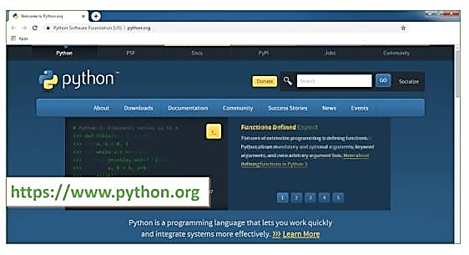Step 1: Go to the official site to download and install python using Google Chrome or any other web browser. OR Click on the following link: [https://www.python.org](https://www.python.org/)

Now, check for the latest and the correct version for your operating system.

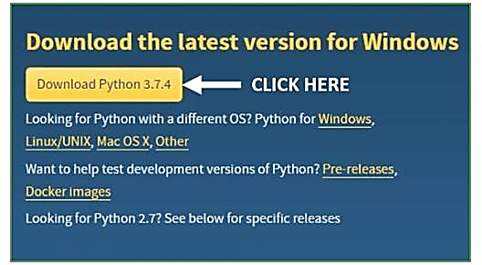

23

Step 2: Click on the Download Tab.

Step3**:** You can either select the Download Python for windows 3.7.4 button in Yellow Color or you can scroll further down and click on download with respective to their version. Here, we are downloading the most recent python version for windows 3.7.4

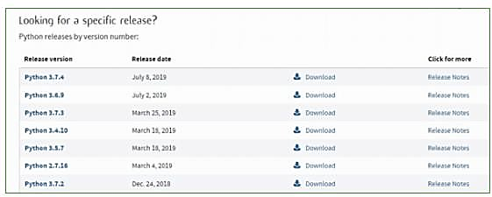

Step 4: Scroll down the page until you find the Files option.

Step 5: Here you see a different version of python along with the operating system.

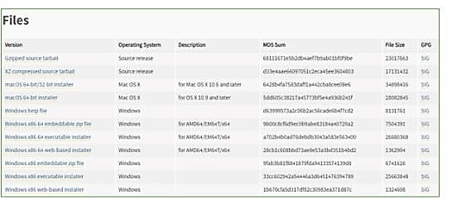

To download Windows 32-bit python, you can select any one from the three options: Windows x86 embeddable zip file, Windows x86 executable installer or Windows x86 web-based installer. To download Windows 64-bit python, you can select any one from the three options: Windows x86-64 embeddable zip file, Windows x86-64 executable installer or Windows x86-64 web-based installer. Here we will install Windows x86-64 web-based installer. Here your first part regarding which version of python is to be downloaded is completed. Now we move ahead with the second part in installing python i.e. Installation.

24

Installation of Python

**Step 1:** Go to Download and Open the downloaded python version to carry out the installation process.

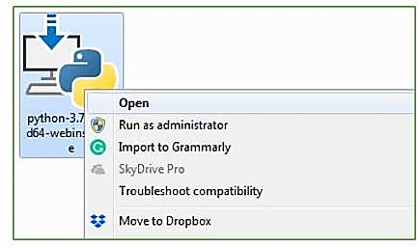

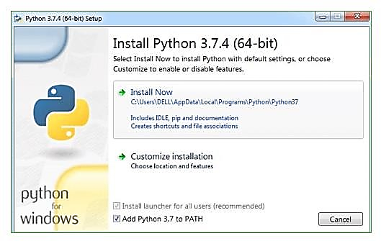**Step 2:** Before you click on Install Now, Make sure to put a tick on Add Python 3.7 to PATH.

Step 3:Click on Install NOW After the installation is successful. Click on Close.

25

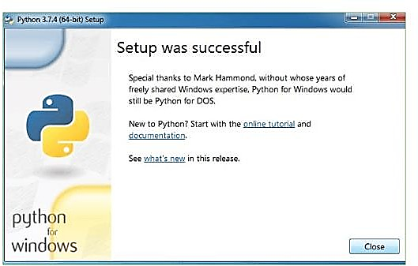

With these above three steps on python installation, you have successfully and correctly installed Python. Now is the time to verify the installation.

Note: The installation process might take a couple of minutes.

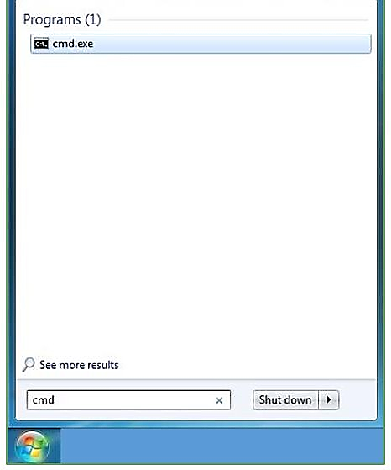Verify the Python Installation

Step 1: Click on Start

Step 2: In the Windows Run Command, type “cmd”.

Step 3**:** Open the Command prompt option.

26

Step 4:Let us test whether the python is correctly installed. Type **python –V** and press Enter.

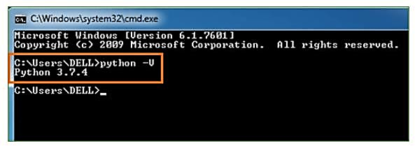

Step 5**:** You will get the answer as 3.7.4

**Note:** If you have any of the earlier versions of Python already installed. You must first uninstall the earlier version and then install the new one.

Check how the Python IDLE works

Step 1**:** Click on Start

Step 2:In the Windows Run command, type “python idle”.

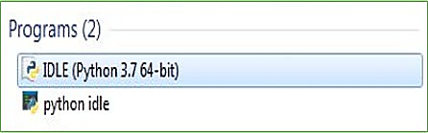

Step 3: Click on IDLE (Python 3.7 64-bit) and launch the program

Step 4: To go ahead with working in IDLE you must first save the file. Click on File > Click on Save

27

26

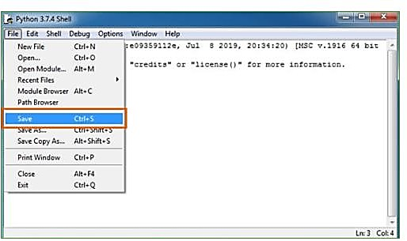Step 5: Name the file and save as type should be Python files. Click on SAVE. Here I have named the files as Hey World.

Step 6: Now for e.g. enter print

28

**CHAPTER-7**

**System Design**

**Chapter-7**

**System Design**

The System Design phase defines how the Schema Validator and Visualizer will be structured and implemented to fulfill the functional and performance requirements defined in the previous sections. This section includes the design of the data flow, architecture, and important components that contribute to the overall functioning of the system.

**7.1 Introduction**

The Schema Validator and Visualizer system aims to help developers and data architects validate, visualize, and troubleshoot schema-based data formats such as JSON, XML, and YAML. The system will consist of multiple interconnected components, including user interfaces, schema parsers, data validators, visualizers, and a backend for data processing. In this section, we provide an overview of the architecture and key components of the system, as well as the interaction between the different modules. The system will be designed to be modular, scalable, and flexible, supporting various schema formats and ensuring ease of integration with existing systems.

System Architecture Overview: The Schema Validator and Visualizer system follows a client-server architecture:

Frontend (Client-side):The client-side will have a user-friendly interface built using HTML, CSS, JavaScript, and optionally, frameworks like React.js or Flask (for web-based applications). This will be responsible for accepting schema and data inputs, displaying validation results, and rendering the visualized schema graph.

Backend (Server-side):The server-side, built using Python, will handle schema parsing, validation, and visualization logic. The server will process the uploaded data against schemas and return error reports, visualization data, and results. The server will communicate with databases or external services if needed.

Schema Validation:The validation process will involve matching user-uploaded data against a predefined schema (in JSON, XML, or YAML format). The backend will use libraries like jsonschema, lxml, or PyYAML for parsing and validation.

Schema Visualization: Graphviz or similar libraries will be used to generate visual representations of the schema structure. The backend will handle the generation of these visualizations and send the results to the frontend for rendering. Data Flow: Data input from users, schema validation, and visualization generation are handled as separate processes. Data is uploaded, parsed, validated, and, based on the results, visualized and returned to the user interface for presentation.

Design Considerations:

Modularity: The system will be modular, with separate modules for schema validation, visualization, error handling, and data input. This ensures that any updates or changes to one module do not affect the others. Scalability:

The design will allow for future enhancements, such as supporting additional schema formats or adding more complex validation rules without impacting existing functionality. Usability:The interface will be designed for ease of use, with a clear and concise display of validation errors and schema visualizations. Users can easily upload schemas, validate data, and view results in real time.

29

**7.2 Data Workflow**

The Data Workflow outlines the sequence of operations involved in processing user inputs, performing schema validation, and visualizing schemas. This workflow is crucial to understanding how data flows through the system from start to finish.

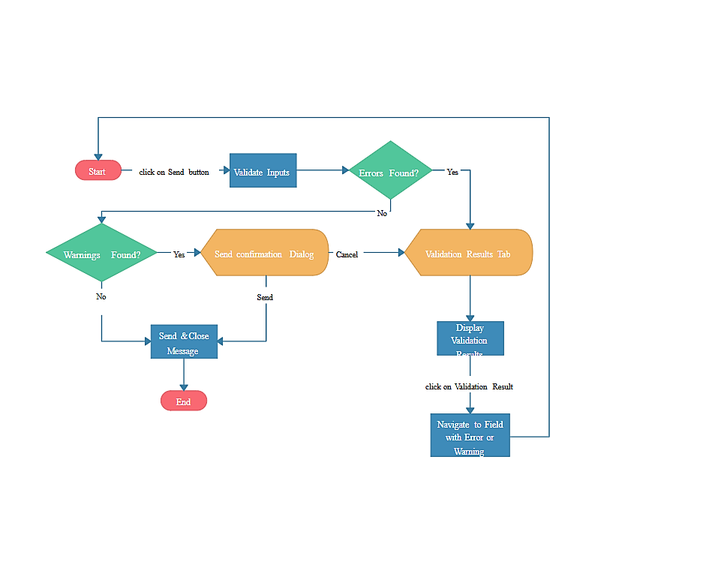

Data Flow Steps:

User Input (Data Upload): The user uploads a schema file (in JSON, XML, or YAML) and a data file (in JSON or XML) to the system. This can be done via drag-and-drop functionality or a file selection dialog in the frontend.The user can also specify additional parameters, such as validation settings or schema versioning. Schema and Data Parsing: Backend: Once the schema and data are uploaded, the backend parses the schema and data files. For JSON and XML, the system uses jsonschema and lxml (for XML) or other suitable libraries to parse the respective schema and data formats. YAML schemas are parsed using the PyYAML library. Schema Validation: The system compares the uploaded data against the provided schema. Validation checks are performed, such as: Type matching: Ensuring that the data type matches the schema type (e.g., string, integer, boolean). Required fields: Checking if required fields are present in the data. Data constraints: Ensuring data values meet predefined constraints (e.g., minimum or maximum values).

30

Nested structure validation: Ensuring the hierarchical structure of the data matches the schema’s nested objects and arrays. Error Reporting: If the data does not conform to the schema, validation errors are generated. The system reports these errors with specific details, such as the type of error, the affected data fields, and suggested fixes.The error report is sent back to the frontend for display. Errors will be presented in an easy-to-understand format with line numbers and descriptions. Schema Visualization: Backend: Once the schema is validated, the backend generates a visual representation of the schema using Graphviz or a similar tool. The schema’s structure (entities, relationships, attributes) is converted into a graph format (e.g., a .dot file), which is then rendered into a graphical image. The generated graph is sent to the frontend for display.

Frontend Display: Frontend: The validated data and error messages are displayed on the user interface. Users can interact with the visualized schema (e.g., zoom in/out, hover over nodes to view details). If the schema is invalid, errors will be highlighted in the input fields or shown in an error log. Users can also download the validation results and visualizations in various formats (e.g., PDF, CSV, PNG). Export and Report Generation: The user can export the validation results (in CSV, PDF, or TXT) and the schema visualization (in PNG, SVG).

This allows the user to save and share the results of their validation and schema design.

**7.3 UML Diagrams**

**7.3.1.Class Diagram**:

The class diagram is used to refine the use case diagram and define a detailed design of the system. The class diagram classifies the actors defined in the use case diagram into a set of interrelated classes. The relationship or association between the classes can be either an “is-a” or “has-a” relationship. Each class in the class diagram may be capable of providing certain functionalities. These functionalities provided by the class are termed “methods” of the class. Apart from this, each class may have certain “attributes” that uniquely.

## 7.3.2.Use case Diagram:

A use case diagram in the Unified Modeling Language (UML) is a type of behavioral diagram defined by and created from a Use-case analysis. Its purpose is to present a graphical overview of the functionality provided by a system in terms of actors, their goals (represented as use cases), and any dependencies between those use cases. The main purpose of a use case diagram is to show what system functions are performed for which actor. Roles of the actors in the system can be depicted.

31



Use case Diagram

32

## 7.3.3.Sequence Diagram:

A sequence diagram represents the interaction between different objects in the system. The important aspect of a sequence diagram is that it is time-ordered. This means that the exact sequence of the interactions between the objects is represented step by step. Different objects in the sequence diagram interact with each other by passing “messages”.

Sequence Graph

## 7.3.4.Collaboration Diagram

A collaboration diagram groups together the interactions between different objects. The interactions are listed as numbered interactions that help to trace the sequence of the interactions. The collaboration diagram helps to identify all the possible interactions that each object has with other objects.



33

**Chapter-8**

**IMPLEMENTATION**

**Chapter-8**

**Implementation**

**8.1 Introduction**

The implementation of the Schema Validator and Visualizer system involves multiple stages, from setting up the development environment to coding and testing the system. During this phase, the system’s components are developed, integrated, and tested to ensure that they meet both functional and performance requirements. The system is designed to be modular, making it easier to add new features or make improvements in the future.

The implementation includes: Frontend Development: Creation of the user interface for interacting with the system.

Backend Development: Coding the logic for schema validation and data parsing. Schema Validation Logic: Implementing the core validation logic that checks whether the data conforms to the schema. Schema Visualization: Implementing the functionality to generate a graphical representation of the schema. Data Exporting: Coding the feature to export validation results and visualizations in various formats. Testing: Ensuring all components work seamlessly together. The technology stack chosen for the implementation includes Python for backend development, JavaScript and React.js (or other web frameworks) for frontend development, and libraries like Graphviz for schema visualization and jsonschema for data validation. The system must support multiple schema formats (JSON, XML, YAML), handle various types of data validation, and display error messages or visualizations in a user-friendly manner.

**System Implementations**:

Data Preprocessing: Prepare the textual data by removing noise, such as special characters, punctuation, and stopwords. Tokenize the text into sentences or paragraphs to facilitate sentiment analysis and summarization. Sentiment Analysis Model: Implement or utilize pre-trained sentiment analysis models capable of accurately detecting the sentiment polarity (positive, negative, neutral) of each sentence or paragraph in the text. Consider employing advanced techniques such as deep learning-based models or transformer architectures for improved accuracy.

Summarization Model: Implement a text summarization model capable of generating concise summaries while incorporating sentiment information. Explore both extractive and abstractive summarization techniques, considering factors such as coherence, informativeness, and sentiment preservation. Integration: Integrate the sentiment analysis module with the summarization module to leverage sentiment information during the summarization process. Design mechanisms to prioritize or adjust the inclusion of sentences based on their sentiment polarity to ensure that the generated summaries reflect the emotional context of the original text.

Evaluation: Evaluate the performance of the implemented system using standard metrics such as ROUGE (Recall-Oriented Understudy for Gisting Evaluation) for summarization quality and sentiment classification accuracy metrics for sentiment analysis. Conduct thorough evaluations using benchmark datasets to assess the effectiveness and robustness of the system.

34

Optimization: Optimize the system for efficiency and scalability by leveraging techniques such as parallel processing, caching, and model compression. Consider deploying the system on distributed computing frameworks or utilizing hardware accelerators (e.g., GPUs) to improve processing speed and resource utilization. User Interface: Develop a user-friendly interface for interacting with the system, allowing users to input text and view the generated summaries along with sentiment analysis results. Design the interface to be intuitive, responsive, and accessible across different devices and platforms. Deployment: Deploy the implemented system in production environments, considering factors such as scalability, reliability, and security. Ensure proper monitoring and maintenance procedures are in place to address potential issues and ensure continuous performance optimization.

Feedback Loop: Establish a feedback loop to gather user feedback and monitor system performance over time. Use feedback to iteratively improve the system's accuracy, usability, and effectiveness based on user requirements and evolving needs.

Algorithm for Schema Validator and Visualizer

Step-by-Step Algorithm:

Step 1: Load Dataset, Accept a dataset file (CSV, JSON, Excel, etc.)., Identify the structure (columns, data types, missing values). Load a predefined schema or allow users to define schema rules.

Step 2: Schema Validation, Compare dataset columns with schema columns. Check if all required columns exist. Identify extra or missing columns. Verify data types (e.g., string, integer, float, date). Detect missing values and duplicates. Identify outliers in numerical data.

Step 3: Schema Violation Detection, Generate a validation report showing Column mismatches Data type mismatches Missing values count Duplicate values Outliers detected Provide automated suggestions for correction.

Step 4: Schema Visualization Generate graphs and tables for analysis:

Bar chart → Data type distribution , Heatmap → Missing values, Box plot → Outliers in numerical columns

Pie chart → Categorical data distribution

Step 5: User Interaction & Reporting Allow users to define custom schema rules for validation. Display validation results in GUI/Web dashboard. Export the report as CSV, JSON, or PDF.

**8.2 SDLC Methodologies**

The Software Development Life Cycle (SDLC) methodologies provide a structured approach to developing software, ensuring that each phase of development is properly planned, executed, and tested. For the Schema Validator and Visualizer system, we will use an Agile SDLC methodology, which allows for flexibility, iterative development, and continuous improvement.

Agile SDLC Methodology

The Agile SDLC approach focuses on delivering small, incremental improvements to the system over short iterations or sprints. It is a flexible and collaborative methodology that allows developers to make frequent adjustments based on feedback, changes in requirements, or emerging issues. The Agile methodology encourages ongoing communication between the development team, project stakeholders, and users, ensuring that the final product meets user needs and expectations.

35

Iterative Development: The system is developed in small, manageable chunks or sprints, each producing a functional part of the system. After each sprint, the team reviews progress, gathers feedback, and plans the next iteration.Collaboration: Frequent interactions and collaboration between developers, designers, and stakeholders ensure that the product evolves in the right direction and that any issues are promptly addressed.

33

Continuous Testing: Testing is performed after each sprint to ensure that new features and bug fixes do not break existing functionality. This helps identify issues early and reduces the chances of defects in the final product.

Customer Feedback: After every sprint, a working version of the system is presented to the stakeholders or customers. Their feedback is incorporated into the next iteration, helping developers ensure the system meets user expectations.

Phases of Agile Methodology for Schema Validator and Visualizer

The Agile SDLC process for the Schema Validator and Visualizer will involve the following key phases:

Requirement Gathering and Analysis: During the first phase, the development team works closely with stakeholders to gather all functional and non-functional requirements for the system. This includes understanding the user needs, defining system requirements, and identifying technical specifications (e.g., supported file formats, validation rules).

System Design: The system design is refined in this phase, with detailed planning of the architecture, user interface, and core modules for schema validation, visualization, and error handling. The design is broken into smaller tasks or stories to be developed incrementally.

Implementation and Coding: This phase involves the actual coding of the system components: Frontend: Building the user interface for data upload, validation, and schema visualization. Backend: Implementing the logic for parsing schemas, validating data, generating errors, and visualizing schema structures.

Testing: Unit Testing: Developers write unit tests for individual components of the system (e.g., schema validation modules, error handling logic). Integration Testing: After individual components are tested, the system is tested as a whole to ensure that all modules work together as expected. User Acceptance Testing (UAT): Stakeholders and users test the system to verify that it meets the requirements and provides the expected functionalities.

Deployment: Once the system is fully tested and approved, it is deployed to the production environment. For a web-based system, this would involve deploying it to a cloud server (e.g., AWS, Google Cloud).

Maintenance and Feedback: After deployment, the system will enter the maintenance phase, where it will be regularly updated to fix bugs, improve performance, and add new features based on user feedback. Continuous monitoring of the system will ensure that any issues are identified and addressed promptly.

36

# 8.3 Architecture analysis:

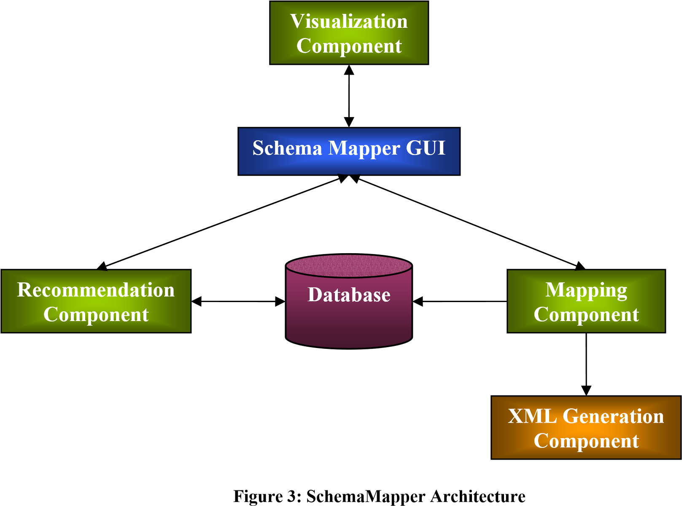

Visualization Component

This component is responsible for all the functions related to visualization of the entire schema mapping process. At present, one visualization method has been implemented for representing the schemas, which employs a hyperbolic tree representation. At any given time, two schemas can be opened for mapping, one local schema and one global schema. This terminology arises primarily from the ETANA-DL domain. A local schema denotes the schema for any new site from which data must be harvested into the Union Catalog. The global schema describes the data stored in the global ETANA database. Although the local schema can be in various formats, support for XMLXML schema mapping has currently been implemented in the tool. In the future, this can be extended to allow database-XML schema mapping as well.

Five main colors are used for the entire process of visualization. The root node is represented in the color yellow, the leaf nodes in green, and the rest of the nodes (that are non-leaf nodes) are in orange. This makes it easy to distinguish among the different types of nodes. It is important to do so because direct mappings among nodes can be established only between leaf nodes since they are the data-containing nodes. Non-leaf local nodes also can be mapped, but only if added as child nodes of global nodes. Also, one-to-one mappings and adding child node types of mappings have been explored in the current prototype. Many-to-one and other complex mappings can be easily added in the future due to the flexible componentized architecture of SchemaMapper.

37

**8.4 Modules Used in Project :-**

the main modules you would use to develop a Schema Visualizer and Validator:

Schema Visualization Module: This module is responsible for taking the database schema (or data model) and generating a graphical representation. Database Schema Parser Purpose: To parse the schema (whether from SQL files, ERD definitions, or database connections). Technologies/Tools: Python libraries like sqlparse, pyodbc, or SQLAlchemy can be used to parse database schemas. Features: Parse DDL scripts (CREATE TABLE, ALTER, etc.), capture table relationships (primary and foreign keys), and map the schema structure.

Graphical Representation Purpose: To render the schema visually using diagrams. Technologies/Tools: Libraries like Graphviz, D3.js, or Mermaid.js for dynamic, interactive schema visualization. Features: Generate interactive ER diagrams that display tables, columns, relationships (one-to-many, many-to-many), and constraints.

Interaction Layer- Purpose: To allow users to interact with the schema visually, such as zooming, searching, and toggling specific entities. Technologies/Tools: Frontend frameworks such as React, Vue.js, or Angular for building interactive user interfaces. Visualization libraries like JointJS or GoJS can also help build complex diagrams.

Schema Validation Module: This module is designed to check the integrity, consistency, and correctness of the schema.Schema Integrity Validator. Purpose: To validate the structural integrity of the schema (e.g., ensuring that foreign keys reference valid primary keys). Technologies/Tools: SQL-based checks, custom Python scripts using libraries like pyodbc, or integrated tools like Liquibase or Flyway for version control and migrations.

Features: Check for missing relationships, missing indexes, redundant columns, and invalid references.

Normalization Validator Purpose: To ensure that the database schema follows normalization rules (1NF, 2NF, 3NF, etc.) to avoid redundancy and ensure data integrity. Technologies/Tools: Custom Python or SQL scripts to analyze relationships and identify potential normalization issues. Features: Identifying violation of normalization forms, detecting potential for data redundancy, and suggesting improvements.

Data Type Validator - Purpose: To ensure that the correct data types are used for each column (e.g., ensuring that a date column isn’t using a string type). Technologies/Tools: SQL parsing tools, custom validation logic in Python or JavaScript. Features: Checking for mismatched data types, ensuring constraints (like NOT NULL, UNIQUE), and checking the maximum lengths of string fields.

Referential Integrity Validator - Purpose: To validate that foreign key relationships are properly defined and maintained.Technologies/Tools: SQL scripts to check for orphaned records or missing foreign key references.

Features: Ensuring that every foreign key in the schema properly references a corresponding primary key in another table. Performance and Index Validator: Purpose: To identify performance bottlenecks and ensure the schema uses appropriate indexing. Technologies/Tools: SQL analysis tools or Python scripts that analyze query performance.

Features: Checking if indexes are defined on columns used frequently in WHERE or JOIN clauses, and suggesting improvements.

Database Connection and Integration Module: This module is responsible for interacting with different databases (SQL or NoSQL) to retrieve schema information.

Database Connector - Purpose: To allow the visualizer and validator to connect to different types of databases and fetch schema information. Technologies/Tools: Libraries like SQLAlchemy (Python), JDBC (Java), pyodbc, or node-postgres (for Node.js) for establishing database connections. Features: Connects to databases (PostgreSQL, MySQL, Oracle, SQL Server, etc.), retrieves schema metadata, and stores it in a standard format for visualization and validation. Data Migration & Synchronization Purpose: To ensure that changes to the schema (such as table alterations or additions) are tracked and updated correctly. Technologies/Tools: Tools like Liquibase or Flyway for managing schema migrations and versioning. Features: Automatically applies schema changes and updates, tracks historical changes to the schema, and provides rollback capabilities.

38

User Interface (UI) Module This module is focused on creating an interactive interface for users to visualize, interact with, and validate schemas. Frontend Framework:Purpose: To provide an intuitive and interactive front-end user interface.Technologies/Tools: React, Angular, or Vue.js for building the user interface. You might also use Bootstrap or Material UI for UI components.Features: Display visualized schemas, allow user interactions such as zooming, filtering, and toggling table views. Enable schema validation reporting and error highlighting.

Interactive Visualization: Purpose: To present the schema dynamically. Technologies/Tools: D3.js, Graphviz, or JointJS can be used for rendering diagrams that allow real-time updates, interactivity, and zoomable/pannable views.

Validation Feedback: Purpose: To provide users with immediate feedback regarding schema validation results.

Technologies/Tools: HTML, CSS, JavaScript for displaying feedback results in a clean, easy-to-read format.

Features: Highlight errors and warnings in the schema (e.g., red for errors, yellow for warnings), provide explanations for validation issues, and suggest fixes.

Reporting and Logging Module: This module generates and logs validation reports.

Validation Report Generator: Purpose: To generate a report detailing the validation results (pass/fail) for each rule applied.Technologies/Tools: Python libraries like reportlab for generating PDF reports or jsPDF for client-side PDF generation in JavaScript. Features: Generate downloadable reports (PDF/HTML) with detailed validation results, error summaries, and suggestions for improvements. Logging and Analytics Purpose: To track changes in the schema and validate over time, providing insights into common issues. Technologies/Tools: Logging frameworks like Log4j (Java), Winston (Node.js), or Python's logging module for tracking events. Features: Log user interactions, validation errors, and successful operations for auditing purposes. This can also help improve the tool by tracking recurring issues or trends.

Pseudocode for Schema Validator and Visualizer

# Step 1: Load Dataset

def load_dataset(file_path):

if file_path.endswith('.csv'):

data = pd.read_csv(file_path)

elif file_path.endswith('.json'):

data = pd.read_json(file_path)

elif file_path.endswith('.xlsx'):

data = pd.read_excel(file_path)

return data

39

# Step 2: Validate Schema

def validate_schema(data, schema):

report = {}

# Check missing columns

missing_columns = set(schema.keys()) - set(data.columns)

report['missing_columns'] = list(missing_columns)

# Check extra columns

extra_columns = set(data.columns) - set(schema.keys())

report['extra_columns'] = list(extra_columns)

# Check data types

report['type_mismatches'] = {}

for col, expected_type in schema.items():

if col in data.columns and data[col].dtype != expected_type:

report['type_mismatches'][col] = (data[col].dtype, expected_type)

# Check missing values

report['missing_values'] = data.isnull().sum().to_dict()

return report

# Step 3: Detect Schema Violations

def detect_violations(report):

print("Schema Validation Report:")

print("Missing Columns:", report['missing_columns'])

print("Extra Columns:", report['extra_columns'])

print("Data Type Mismatches:", report['type_mismatches'])

print("Missing Values:", report['missing_values'])

# Step 4: Visualize Schema

def visualize_schema(data):

import seaborn as sns

import matplotlib.pyplot as plt

# Missing Values Heatmap

40

plt.figure(figsize=(10,6))

sns.heatmap(data.isnull(), cmap='coolwarm', cbar=False)

plt.title("Missing Values Heatmap")

plt.show()

# Data Type Distribution

data_types = data.dtypes.value_counts()

plt.figure(figsize=(6,4))

data_types.plot(kind='bar', color=['blue', 'green', 'red'])

plt.title("Data Type Distribution")

plt.show()

# Step 5: Main Execution

if __name__ == "__main__":

file_path = "dataset.csv"

schema = {"name": "object", "age": "int64", "salary": "float64"}

data = load_dataset(file_path)

validation_report = validate_schema(data, schema)

detect_violations(validation_report)

visualize_schema(data)

**8.5 Source code:**

App.py

from flask import Flask, render_template, request, redirect, make_response, send_file

import os

import pandas as pd

import numpy as np

import models as algorithms

import plotfunctions as plotfun

from matplotlib.backends.backend_agg import FigureCanvasAgg as FigureCanvas

from io import BytesIO

from flask_bootstrap import Bootstrap

app = Flask(__name__)

bootstrap = Bootstrap(app)

def datasetList():

41

    datasets = [x.split('.')[0] for f in ['datasets', 'preprocessed'] for x in os.listdir(f)]

    extensions = [x.split('.')[1] for f in ['datasets', 'preprocessed'] for x in os.listdir(f)]

    folders = [f for f in ['datasets', 'preprocessed'] for x in os.listdir(f)]

    return datasets, extensions, folders

#Load columns of the dataset

def loadColumns(dataset):

    datasets, extensions, folders = datasetList()

    if dataset in datasets:

        extension = extensions[datasets.index(dataset)]

        if extension == 'txt':

            df = pd.read_table(os.path.join(folders[datasets.index(dataset)], dataset + '.txt'), nrows=0)

        elif extension == 'csv':

            df = pd.read_csv(os.path.join(folders[datasets.index(dataset)], dataset + '.csv'), nrows=0)

        return df.columns

#Load Dataset

def loadDataset(dataset):

    datasets, extensions, folders = datasetList()

    if dataset in datasets:

        extension = extensions[datasets.index(dataset)]

        if extension == 'txt':

            df = pd.read_table(os.path.join(folders[datasets.index(dataset)], dataset + '.txt'))

        elif extension == 'csv':

            df = pd.read_csv(os.path.join(folders[datasets.index(dataset)], dataset + '.csv'))

        return df

@app.route('/', methods = ['GET', 'POST'])

def index():

    datasets,_,folders = datasetList()

    originalds = []

    featuresds = []

    for i in range(len(datasets)):

        if folders[i] == 'datasets': originalds += [datasets[i]]

        else: featuresds += [datasets[i]]

    if request.method == 'POST':

            f = request.files['file']

            f.save(os.path.join('datasets', f.filename))

            return redirect('/')

    return render_template('index.html', originalds = originalds, featuresds = featuresds)

42

@app.route('/datasets/')

def datasets():

    return redirect('/')

@app.route('/datasets/<dataset>')

def dataset(description = None, head = None, dataset = None):

    df = loadDataset(dataset)

    try:

        description = df.describe().round(2)

        head = df.head(5)

    except: pass

    return render_template('dataset.html',

                           description = description.to_html(classes='table table-striped table-hover'),

                           head = head.to_html(index=False, classes='table table-striped table-hover'),

                           dataset = dataset)

@app.route('/datasets/<dataset>/models')

def models(dataset = dataset):

    columns = loadColumns(dataset)

    clfmodels = algorithms.classificationModels()

    predmodels = algorithms.regressionModels()

    return render_template('models.html', dataset = dataset,

                           clfmodels = clfmodels,

                           predmodels = predmodels,

                           columns = columns)

@app.route('/datasets/<dataset>/modelprocess/', methods=['POST'])

def model_process(dataset = dataset):

    algscore = request.form.get('model')

    res = request.form.get('response')

    kfold = request.form.get('kfold')

    alg, score = algscore.split('.')

    scaling = request.form.get('scaling')

    variables = request.form.getlist('variables')

    from sklearn.model_selection import cross_validate

    from sklearn.preprocessing import StandardScaler

    from sklearn.pipeline import Pipeline

    df = loadDataset(dataset)

    y = df[str(res)]

    if variables != [] and '' not in variables:

43

        df = df[list(set(variables + [res]))]

    X = df.drop(str(res), axis=1)

    try:

        X = pd.get_dummies(X)

    except:

        pass

    predictors = X.columns

    if len(predictors) > 10:

        pred = str(len(predictors))

    else:

        pred = ', '.join(predictors)

    if score == 'Classification':

        from sklearn.metrics import precision_score, recall_score, f1_score, accuracy_score, roc_curve, auc

        scoring = ['precision', 'recall', 'f1', 'accuracy', 'roc_auc']

        if scaling == 'Yes':

            clf = algorithms.classificationModels()[alg]

            mod = Pipeline([('scaler', StandardScaler()), ('clf', clf)])

        else:

            mod = algorithms.classificationModels()[alg]

        fig = plotfun.plot_ROC(X.values, y, mod, int(kfold))

    elif score == 'Regression':

        from sklearn.metrics import explained_variance_score, r2_score, mean_squared_error

        scoring = ['explained_variance', 'r2', 'mean_squared_error']

        if scaling == 'Yes':

            pr = algorithms.regressionModels()[alg]

            mod = Pipeline([('scaler', StandardScaler()), ('clf', pr)])

        else:

            mod = algorithms.regressionModels()[alg]

        fig = plotfun.plot_predVSreal(X, y, mod, int(kfold))

    scores = cross_validate(mod, X, y, cv=int(kfold), scoring=scoring)

    for s in scores:

        scores[s] = str(round(np.mean(scores[s]), 3))

    # Fixed predictors and response assignment

    predictors = pred

    response = fig

    return render_template('scores.html', scores=scores, dataset=dataset, alg=alg,

44

                           res=res, kfold=kfold, score=score,

                           predictors=predictors, response=response)

@app.route('/datasets/<dataset>/preprocessing')

def preprocessing(dataset = dataset):

    columns = loadColumns(dataset)

    return render_template('preprocessing.html', dataset = dataset, columns=columns)

@app.route('/datasets/<dataset>/preprocessed_dataset/', methods=['POST'])

def preprocessed_dataset(dataset):

    numFeatures = request.form.get('nfeatures')

    manualFeatures = request.form.getlist('manualfeatures')

    datasetName = request.form.get('newdataset')

    response = request.form.get('response')

    dropsame = request.form.get('dropsame')

    dropna = request.form.get('dropna')

    df = loadDataset(dataset)

    if dropna == 'all':

        df = df.dropna(axis=1, how='all')

    elif dropna == 'any':

        df.dropna(axis=1, how='any')

    filename = dataset + '_'

    try:

        nf = int(numFeatures)

        from sklearn.feature_selection import SelectKBest, chi2

        X = df.drop(str(response), axis=1)

        y = df[str(response)]

        kbest = SelectKBest(chi2, k=nf).fit(X,y)

        mask = kbest.get_support()

        # List of K best features

        best_features = []

        for bool, feature in zip(mask, list(df.columns)):

            if bool: best_features.append(feature)

        #Reduced Dataset

        df = pd.DataFrame(kbest.transform(X),columns=best_features)

        df.insert(0, str(response), y)

        filename += numFeatures + '_' + 'NA' + dropna + '_Same' + dropsame + '.csv'

    except:

        df = df[manualFeatures]

45

        filename += str(datasetName) + '_' + str(response) + '.csv'

    if dropsame == 'Yes':

        nunique = df.apply(pd.Series.nunique)

        cols_to_drop = nunique[nunique == 1].index

        df = df.drop(cols_to_drop, axis=1)

    df.to_csv(os.path.join('preprocessed', filename), index=False)

    return redirect('/datasets/' + filename.split('.')[0])

@app.route('/datasets/<dataset>/graphs')

def graphs(dataset = dataset):

    columns = loadColumns(dataset)

    return render_template('graphs.html', dataset = dataset, columns=columns)

@app.route('/datasets/<dataset>/graphprocess/', methods=['POST'])

def graph_process(dataset):

    histogram = request.form.getlist('histogram')

    boxplotcat = request.form.get('boxplotcat')

    boxplotnum = request.form.get('boxplotnum')

    corr = request.form.getlist('corr')

    ds = loadDataset(dataset)

    figs = {}

    if histogram:

        figs['Histograms'] = plotfun.plot_histsmooth(ds, histogram)

    if corr:

        figs['Correlations'] = plotfun.plot_correlations(ds, corr)

    if boxplotcat and boxplotnum:

        figs['Box Plot'] = plotfun.plot_boxplot(ds, boxplotcat, boxplotnum)

    if not figs:

        return redirect(f'/datasets/{dataset}/graphs')

    return render_template('drawgraphs.html', figs=figs, dataset=dataset)

@app.route('/datasets/<dataset>/predict')

def predict(dataset = dataset):

    columns = loadColumns(dataset)

    clfmodels = algorithms.classificationModels()

    predmodels = algorithms.regressionModels()

    return render_template('predict.html', dataset = dataset,

                           clfmodels = clfmodels,

                           predmodels = predmodels,

                           columns = columns)

46

@app.route('/datasets/<dataset>/prediction/', methods=['POST'])

def predict_process(dataset = dataset):

    algscore = request.form.get('model')

    res = request.form.get('response')

    alg, score = algscore.split('.')

    scaling = request.form.get('scaling')

    df = loadDataset(dataset)

    columns = df.columns

    values = {}

    counter = 0

    for col in columns:

        values[col] = request.form.get(col)

        if values[col] != '' and col != res: counter +=1

    if counter == 0: return redirect('/datasets/' + dataset + '/predict')

    predictors = {}

    for v in values:

        if values[v] != '':

            try: predictors[v] = [float(values[v])]

            except: predictors[v] = [values[v]]

    from sklearn.preprocessing import StandardScaler

    X = df[list(predictors.keys())]

    Xpred = predictors

    #return str(Xpred)

    Xpred = pd.DataFrame(data=Xpred)

    X = pd.concat([X,Xpred])

    X = pd.get_dummies(X)

    Xpred = X.iloc[[-1]]

    X = X[:-1]

    if scaling == 'Yes':

        scaler = StandardScaler()

        X = pd.DataFrame(scaler.fit_transform(X), columns = X.columns)

        Xpred = pd.DataFrame(scaler.transform(Xpred), columns = X.columns)

    try:

        X = X.drop(str(res), axis=1)

        Xpred = Xpred.drop(str(res), axis=1)

    except: pass

    #Xpred.reset_index(drop=True, inplace=True)

47

    #X.reset_index(drop=True, inplace=True)

    y = df[str(res)]

    if score == 'Classification':

            mod = algorithms.classificationModels()[alg]

    elif score == 'Regression':

        mod = algorithms.regressionModels()[alg]

    model = mod.fit(X, y)

    #return pd.DataFrame(Xpred).to_html()

    predictions = {}

    predictions['Prediction'] = model.predict(Xpred)[0]

    predictors.pop(res, None)

    for p in predictors:

        if str(predictors[p][0]).isdigit() is True: predictors[p] = int(predictors[p][0])

        else:

            try: predictors[p] = round(predictors[p][0],2)

            except: predictors[p] = predictors[p][0]

    for p in predictions:

        if str(predictions[p]).isdigit() is True: predictions[p] = int(predictions[p])

        else:

            try: predictions[p] = round(predictions[p],2)

            except: continue

    if len(predictors) > 15: predictors = {'Number of predictors': len(predictors)}

    #return str(predictors) + res + str(predictions) + alg + score

    if score == 'Classification':

        classes = model.classes_

        pred_proba = model.predict_proba(Xpred)

        for i in range(len(classes)):

            predictions['Prob. ' + str(classes[i])] = round(pred_proba[0][i],3)

    return render_template('prediction.html', predictions = predictions, response = res,

                           predictors = predictors, algorithm = alg, score = score,

                           dataset = dataset)

@app.errorhandler(500)

def internal_error(e):

    return render_template('error500.html')

@app.errorhandler(404)

def page_not_found(e):

    return render_template('error404.html')

48

if __name__ == '__main__':

    app.run(debug=False)

plotfunctions.py

import matplotlib

matplotlib.use('Agg')

import matplotlib.pyplot as plt

import numpy as np

import seaborn as sns

from io import BytesIO

import base64

from sklearn.metrics import roc_curve, auc

from sklearn.model_selection import StratifiedKFold, cross_val_predict

from sklearn.preprocessing import label_binarize, LabelEncoder

sns.set(style="whitegrid")

# Function to plot ROC curve

def plot_ROC(X, y, classifier, cv):

cv = StratifiedKFold(n_splits=cv)

le = LabelEncoder()

y_encoded = le.fit_transform(y)

classes = le.classes_

n_classes = len(classes)

plt.figure(figsize=(8, 6))

if n_classes > 2:

y_bin = label_binarize(y_encoded, classes=np.arange(n_classes))

else:

y_bin = y_encoded.reshape(-1, 1)

for i in range(n_classes):

tprs = []

aucs = []

mean_fpr = np.linspace(0, 1, 100)

49

for train, test in cv.split(X, y_encoded):

y_train_bin = y_bin[train][:, i] if n_classes > 2 else y_bin[train]

y_test_bin = y_bin[test][:, i] if n_classes > 2 else y_bin[test]

probas_ = classifier.fit(X[train], y_train_bin).predict_proba(X[test])

if probas_.shape[1] == 1:

probas_ = np.hstack([1 - probas_, probas_])

fpr, tpr, _ = roc_curve(y_test_bin, probas_[:, 1])

tprs.append(np.interp(mean_fpr, fpr, tpr))

tprs[-1][0] = 0.0

roc_auc = auc(fpr, tpr)

aucs.append(roc_auc)

mean_tpr = np.mean(tprs, axis=0)

mean_tpr[-1] = 1.0

mean_auc = auc(mean_fpr, mean_tpr)

std_auc = np.std(aucs)

plt.plot(mean_fpr, mean_tpr, lw=2, alpha=0.8,

label=f'Class {classes[i]} (AUC = {mean_auc:.2f} ± {std_auc:.2f})')

plt.plot([0, 1], [0, 1], linestyle='--', lw=2, color='red', alpha=0.8)

plt.xlim([0.0, 1.0])

plt.ylim([0.0, 1.05])

plt.xlabel('False Positive Rate')

plt.ylabel('True Positive Rate')

plt.title('ROC Curve')

plt.legend(loc='lower right')

return _save_plot_to_base64()

# Function to plot predicted vs real values

def plot_predVSreal(X, y, classifier, cv):

predicted = cross_val_predict(classifier, X, y, cv=cv)

50

plt.figure(figsize=(8, 6))

plt.scatter(y, predicted, edgecolors=(0, 0, 0))

plt.plot([y.min(), y.max()], [y.min(), y.max()], 'k--', lw=2)

plt.xlabel('Measured')

plt.ylabel('Predicted')

plt.title('Predicted vs Real Values')

return _save_plot_to_base64()

# Function to plot smoothed histogram

def plot_histsmooth(data, columns):

sns.set()

plt.figure(figsize=(10, 6))

for column in columns:

if column in data.columns:

sns.histplot(data[column], kde=True, label=column, bins=20)

plt.legend(title="Columns")

plt.title('Smoothed Histogram')

plt.xlabel('Value')

plt.ylabel('Frequency')

return _save_plot_to_base64()

# Function to save plot as base64-encoded PNG

def _save_plot_to_base64(fig=None):

if fig is None:

fig = plt.gcf()

figfile = BytesIO()

fig.savefig(figfile, format='png', bbox_inches='tight')

figfile.seek(0)

encoded_img = base64.b64encode(figfile.getvalue()).decode('utf-8')

plt.close(fig)

return encoded_img

import seaborn as sns

51

import matplotlib.pyplot as plt

from io import BytesIO

import base64

def plot_correlations(ds, columns):

plt.figure(figsize=(10, 8))

sns.heatmap(ds[columns].corr(), annot=True, cmap='coolwarm', fmt='.2f', linewidths=0.5)

figfile = BytesIO()

plt.savefig(figfile, format='png', bbox_inches='tight')

figfile.seek(0)

encoded_img = base64.b64encode(figfile.getvalue()).decode('utf-8')

plt.close()

return encoded_img

import seaborn as sns

import matplotlib.pyplot as plt

from io import BytesIO

import base64

def plot_boxplot(ds, category, value):

try:

plt.figure(figsize=(8, 6))

sns.boxplot(x=ds[category], y=ds[value])

figfile = BytesIO()

plt.savefig(figfile, format='png', bbox_inches='tight')

figfile.seek(0)

encoded_img = base64.b64encode(figfile.getvalue()).decode('utf-8')

plt.close()

return encoded_img

except Exception as e:

print(f"Error in plot_boxplot: {e}")

return None

52

**CHAPTER-9**

**System Testing and Validation**

**CHAPTER-9**

**System Testing and Validation**

**9.1 Introduction**

The System Testing and Validation phase is crucial to guarantee that the Schema Validator and Visualizer works as intended. It involves the execution of various tests to verify the system’s individual components, integration, and overall performance. The goal of this phase is to ensure that all modules and features of the system are working as expected and that the system is free of critical bugs or errors.

The testing process for the Schema Validator and Visualizer system includes:

Unit Testing: Testing individual modules or components for expected behavior.

Integration Testing: Ensuring that the different components of the system work together seamlessly.

System Testing: Comprehensive testing of the entire system to ensure that it meets the defined requirements.

Acceptance Testing: Conducted by stakeholders or end-users to confirm that the system meets their needs.

These tests will be performed iteratively and continuously throughout the development process to identify issues early, ensure the system functions correctly, and verify that the system delivers the required functionality and performance.

**9.2 Module Testing**

Module Testing focuses on testing individual components or modules of the Schema Validator and Visualizer system in isolation. The purpose of module testing is to ensure that each module performs its intended function correctly before integrating it with other components.

The key modules to be tested include:

Schema Parser Module: This module parses schema files (JSON, XML, or YAML) and converts them into a structured format for validation. Unit tests will verify the correct parsing of each schema format. Validation Engine: This module performs the core function of validating data against the uploaded schema. Error Handling Module: This module handles any errors that occur during validation or visualization. It ensures that appropriate error messages are displayed to the user. Visualization Module: This module generates a graphical representation of the schema. It will be tested to ensure that the visual representation is clear, accurate, and properly rendered. Test Case Creation: Each module will have a set of test cases that cover all possible inputs, including valid and invalid data, edge cases, and boundary conditions. Test Execution: Tests are executed for each module, and the results are compared with the expected behavior to identify any discrepancies. Error Logging and Fixes: Any issues discovered during module testing are logged, and the development team fixes the errors before moving to the next level of testing.

49

**9.3 System Testing**

System Testing involves testing the entire Schema Validator and Visualizer system as a whole, ensuring that all modules work together as expected. This type of testing focuses on evaluating the complete system's functionality, performance, security, and usability.

The key objectives of System Testing include:Functionality Testing: Verifying that all system features, such as schema validation, error reporting, and visualization, work as intended. Usability Testing: Ensuring that the user interface is intuitive and that users can easily upload schemas, validate data, and view visualizations. Performance Testing: Evaluating the system’s performance under various conditions (e.g., large schema files, large datasets) to ensure it meets the required performance standards. Security Testing: Ensuring that the system is secure and that sensitive data is not exposed to unauthorized users.

53

System Testing Process: Test Environment Setup: A testing environment is set up to simulate real-world usage, including uploading large schemas, validating complex data, and generating visualizations.

Test Execution: Tests are run based on real-world use cases to validate the system’s functionality and performance. Result Analysis: Test results are analyzed to ensure that the system meets the expected requirements, and any issues are documented for further investigation.

**9.4 Integration Testing**

Integration Testing is conducted after module testing to ensure that individual modules work together as a unified system. The goal is to verify that different parts of the Schema Validator and Visualizer can exchange data correctly and that the entire workflow functions without issues. Frontend and Backend Integration: Ensuring that the frontend correctly interacts with the backend to send schema data, validate input, and display results. Validation Engine and Visualization Module: Ensuring that the validation process works correctly and that the generated errors are passed to the visualization module for graphical representation.

Error Handling Integration: Ensuring that errors are logged and displayed properly when issues occur between the frontend, backend, and modules. Integration Testing Process: Module Connection Setup: Modules that have passed individual tests are connected to form the complete system. Test Execution: Real-world test cases are used to test interactions between integrated modules, ensuring data flows properly across components.

Defect Logging and Fixing: Issues discovered during integration testing are logged, and the development team works to fix them.

**9.5 Acceptance Testing**

Acceptance Testing is conducted to validate that the Schema Validator and Visualizer system meets the requirements and expectations of end users and stakeholders. This testing is typically performed by stakeholders or potential end users who test the system in real-world scenarios.

Acceptance Testing Process: Test Scenarios: Real-world test scenarios are created based on user requirements, such as uploading a schema, validating a large dataset, generating visualizations, and exporting results. Test Execution: Stakeholders perform tests based on the provided scenarios. Their feedback is used to validate the system's functionality and usability. Feedback and Fixes: Any issues identified during acceptance testing are addressed by the development team. The system is refined based on user feedback to meet all requirements.

**9.6 Test Cases**

Test cases are a set of conditions or variables used to verify that a system behaves as expected. For the Schema Validator and Visualizer, test cases cover all aspects of the system, including input validation, schema parsing, data validation, error handling, and visualization generation.

54

Example test cases for the Schema Validator and Visualizer system:

Test Case 1: Valid JSON Schema and Data

Input: Valid JSON schema and matching JSON data.

Expected Output: No validation errors, successful schema visualization.

Test Case 2: Invalid Data Format

Input: Valid JSON schema but invalid XML data.

Expected Output: Schema validation error message indicating an incompatible data format.

Test Case 3: Missing Required Fields

Input: Valid JSON schema with required fields but missing in the uploaded data.

Expected Output: Error message indicating the missing required fields.

Test Case 4: Large Data File

Input: Large JSON or XML dataset.

Expected Output: Successful schema validation or performance issues (if any), based on system requirements.

Test Case 5: Schema Visualization Generation

Input: Valid JSON schema.

Expected Output: Correct visual representation of the schema with clear entities and relationships.

**9.7 Output Screens**

Output Screens are the user interfaces where the results of validation, error reports, and visualizations are displayed to the user

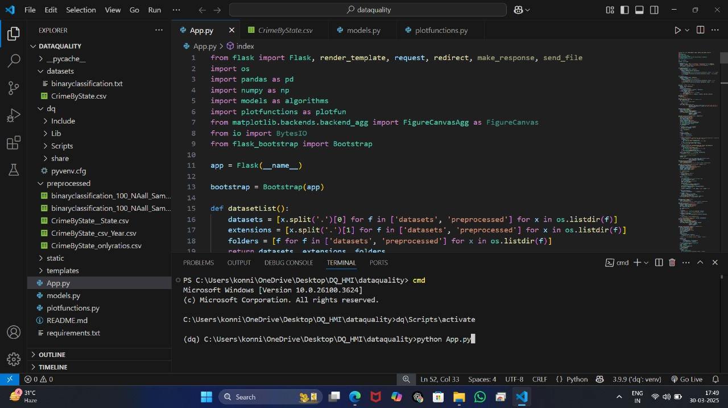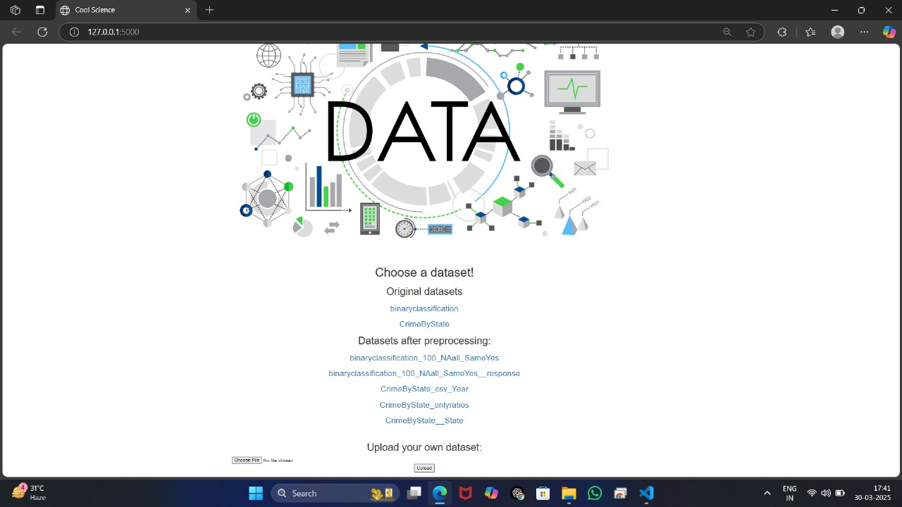

55

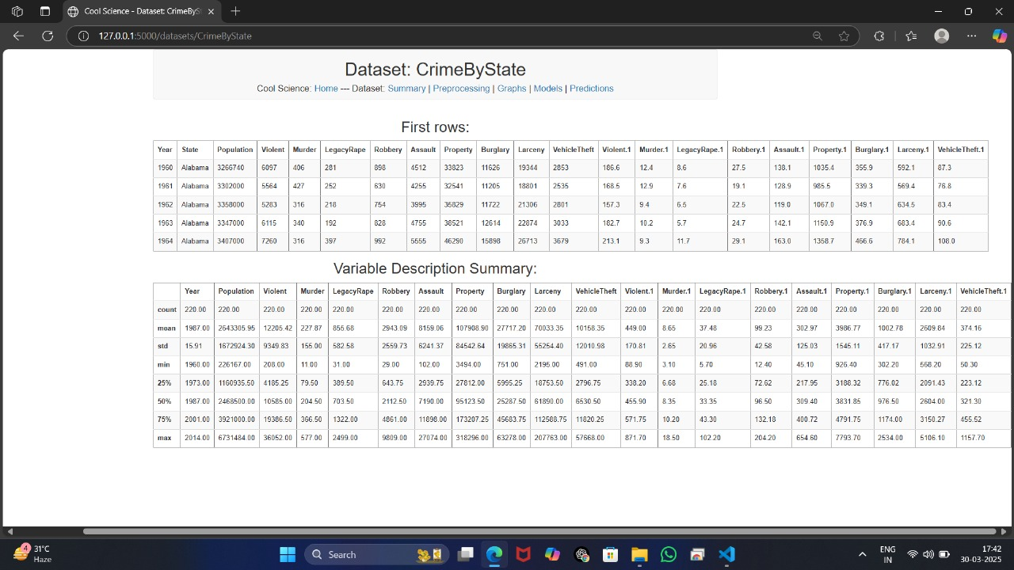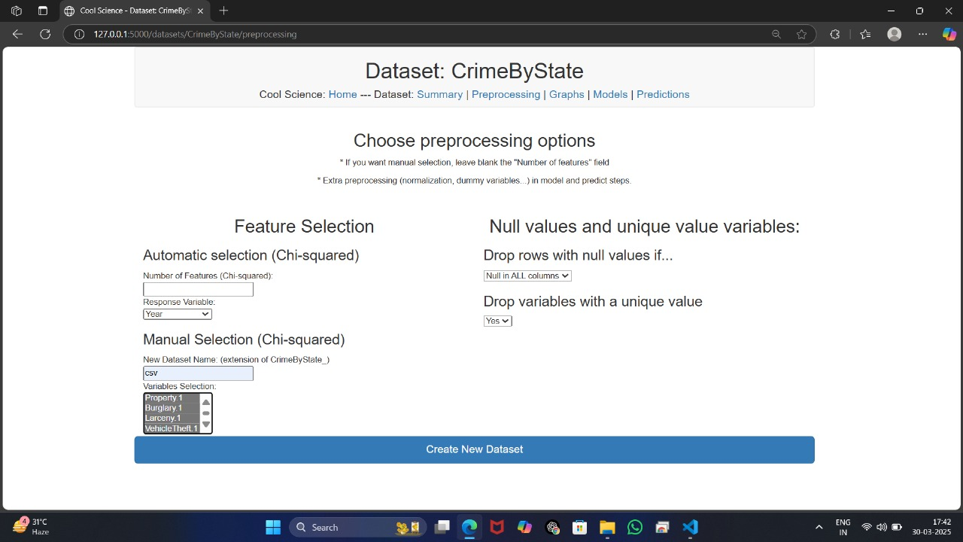

56

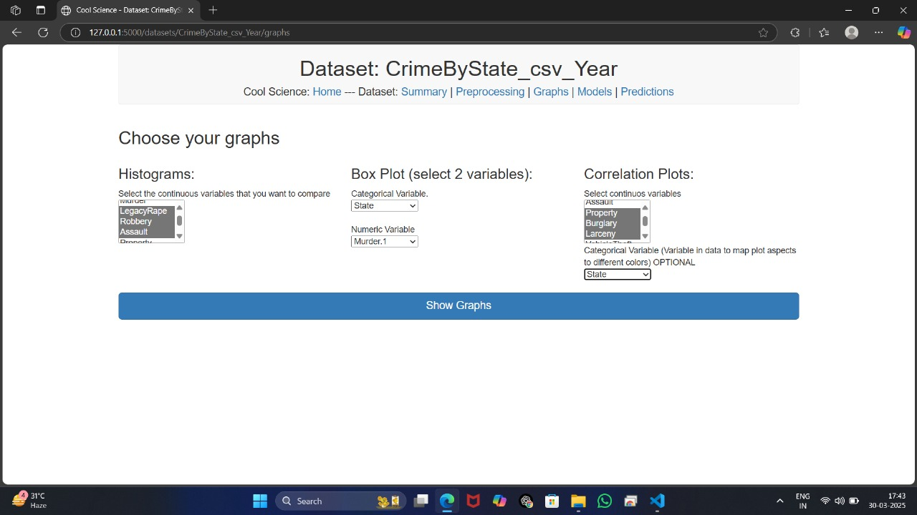

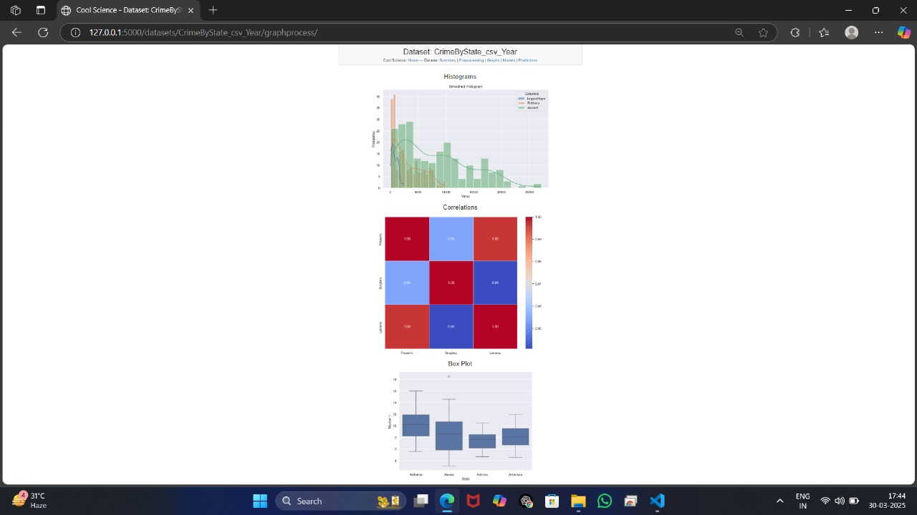

57

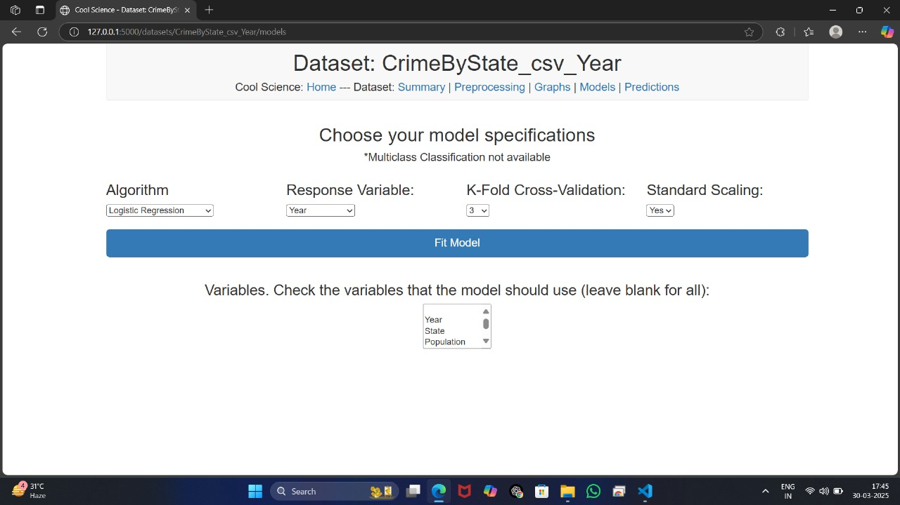

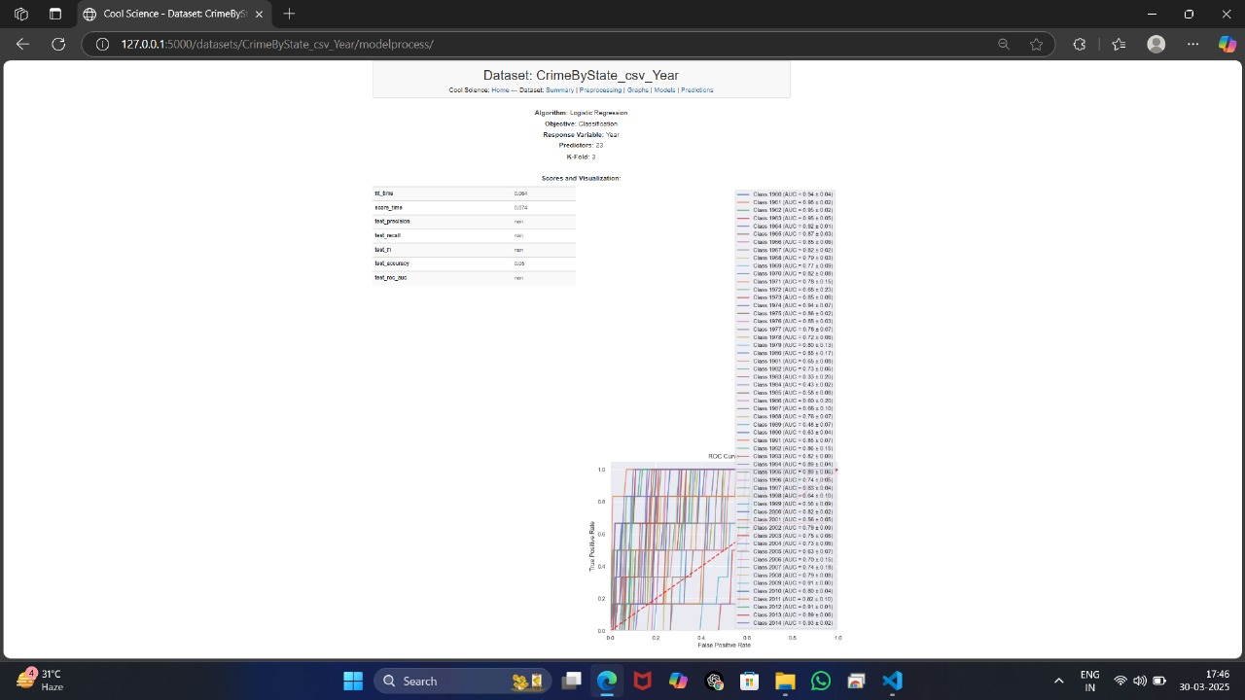

58

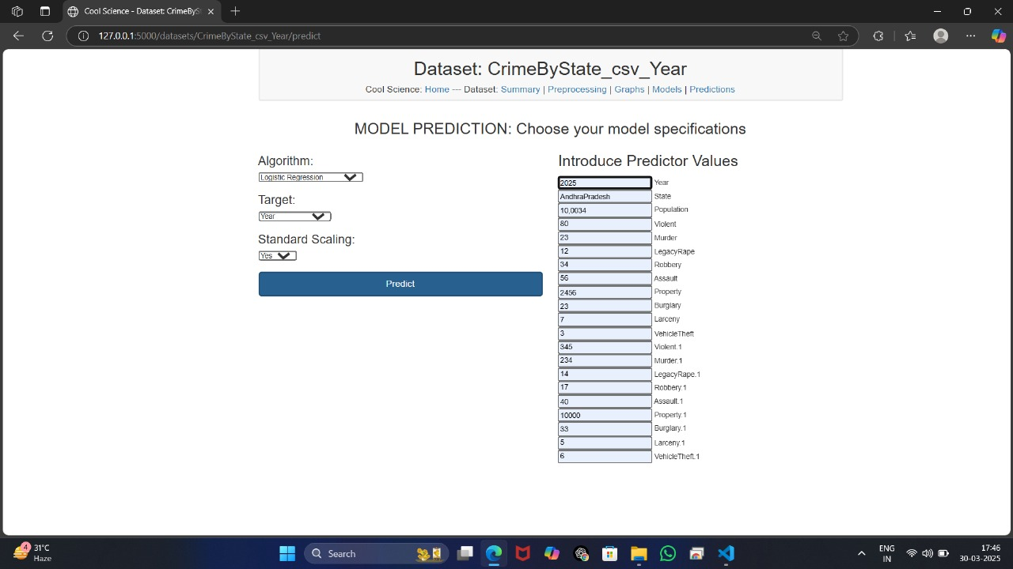

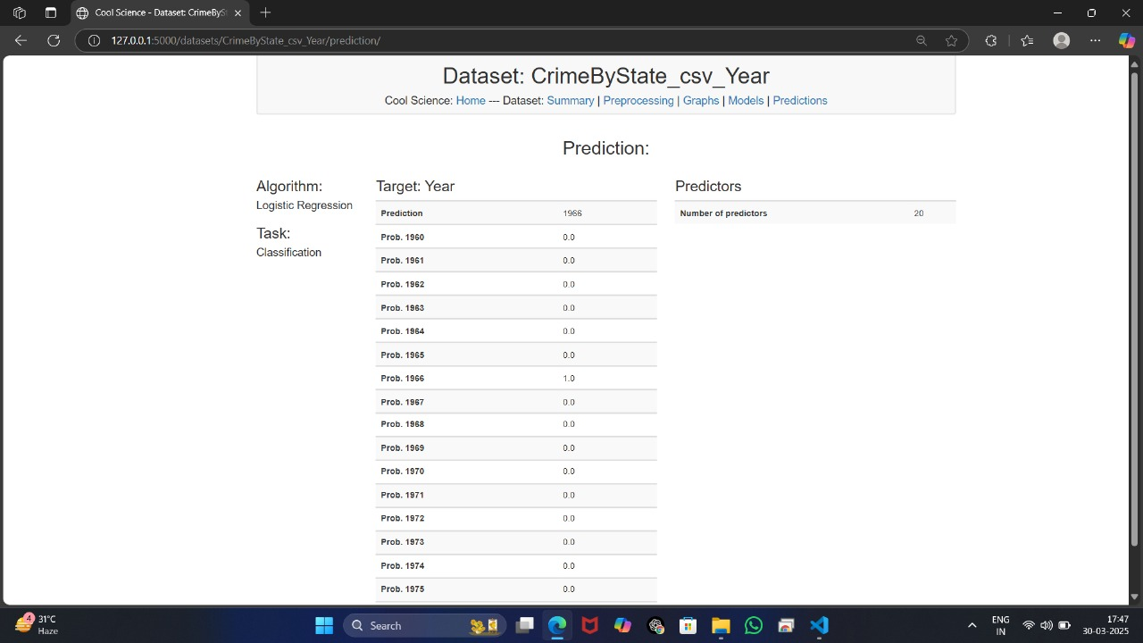

59

**9.8 Conclusion**

The System Testing and Validation phase is essential to ensuring that the Schema Validator and Visualizer system operates as expected and meets the defined functional, performance, and usability requirements. By conducting thorough module testing, system testing, integration testing, and acceptance testing, the development team ensures the system's reliability, accuracy, and usability. Rigorous testing, combined with user feedback, helps create a robust and high-quality product. The Schema Validator and Visualizer is a powerful tool designed to enhance data quality by validating schemas and providing interactive visual representations. In machine learning and data-driven applications, maintaining a consistent and well-defined schema is essential for accurate model predictions and efficient data processing.

This tool addresses key challenges such as schema inconsistencies, manual validation efforts, and limited visualization capabilities. By integrating automated schema validation, anomaly detection, and interactive visualization, it ensures data integrity and improves usability for data engineers, analysts, and machine learning practitioners.

Key benefits of the Schema Validator and Visualizer include:

Automated schema validation to detect errors and inconsistencies. Graphical schema representation for improved interpretability. Scalability to handle large datasets across various domains. Seamless integration with existing machine learning pipelines. By implementing this tool, organizations can significantly improve data governance, reduce errors in data pipelines, and enhance the overall efficiency of their data workflows. Future enhancements may include advanced anomaly detection using machine learning techniques, real-time schema monitoring, and expanded support for various data formats. The Schema Validator and Visualizer contributes to the broader goal of ensuring data quality and reliability, making it a valuable asset for any data-driven project.

**9.9 Future Enhancements**

While the Schema Validator and Visualizer system meets the current requirements, several future enhancements could further improve its capabilities, such as: Support for Additional Schema Formats: Expanding support to include other schema formats like Avro or Protobuf. Advanced Schema Visualization: Adding more advanced visualization options, such as interactive schema diagrams or 3D representations. Real-Time Validation: Implementing real-time validation as users enter or modify data, providing immediate feedback.

Cloud Integration: Enabling users to save their schemas and results in cloud storage for easy access and sharing. Add impact analysis to evaluate how schema changes (like adding or removing a column, changing data types, or modifying relationships) will affect other parts of the system, including dependencies and application behavior. Provides insights into potential side effects of schema changes and reduces the risk of breaking the system when making adjustments. Allow users to define their own schema validation rules or adjust the existing ones. This could involve custom constraints, unique relationships, or performance-based checks that are specific to an organization’s needs. Provides flexibility for teams to implement domain-specific or organization-specific rules, which would make the tool more adaptable to diverse use cases.

60

# 9.10.References

1. Bailey, J., Stuckey, P.J.: Discovery of Minimal Unsatisfiable Subsets of Constraints Using Hitting Set Dualization. PADL 2005, 174-186
2. Farré, C., Teniente, E., Urpí, T.: A New Approach for Checking Schema Validation Properties. DEXA 2004, 77-86
3. Farré, C., Teniente, E., Urpí, T.: Checking Query Containment with the CQC Method. Data Knowl. Eng. 53(2), 163-223 (2005)
4. Halevy, A.Y., Mumick, I.S., Sagiv, Y., Shmueli, O.: Static Analysis in Datalog Extensions. J. ACM 48(5), 971-1012 (2001)
5. Madhavan, J., Bernstein, P.A., Domingos, P., Halevy, A.Y.: Representing and Reasoning about Mappings between Domain Models. AAAI/IAAI 2002, 80-86
6. The Mondial Database.
7. <http://www.dbis.informatik.unigoettingen.de/Mondial/>
8. Queralt, A., Teniente, E.: Reasoning on UML Class Diagrams with OCL Constraints. ER 2006, 497-512
9. Rull, G., Farré, C., Teniente, E., Urpí, T.: Computing Explanations for Unlively Queries in Databases. CIKM 2007, 955-958
10. Teniente, E., Farré, C., Urpí, T., Beltrán, C., Gañán, D.: SVT: Schema Validation Tool for Microsoft SQL-Server. VLDB 2004, 1349-1352
11. Zhang, X., Özsoyoglu, Z.M.: Implication and Referential Constraints: A New Formal
12. Reasoning. IEEE Trans. Knowl. Data Eng. 9(6), 894-910 (1997)
13. Ravindranathan, U., Shen, R., Goncalves, M. A., Fan, W., Fox, E. A., and Flanagan, J. W. *ETANA-DL: A Digital Library For Integrated Handling Of Heterogeneous Archaeological Data*. Presented at Joint Conference on Digital Libraries (JCDL 2004), Tucson, AZ, June 7-11, 2004.

61

1. Nithiwat Kampanya, Rao Shen, Seonho Kim, Chris North, and Edward A. Fox. CitiViz: A Visual User Interface to the CITIDEL System. Full paper in Proc. European Conference on Digital Libraries (ECDL) 2004, September 12-17, 2004, University of Bath, UK.
2. Lamping, J. and Rao, R., *Laying Out and Visualizing Large Trees Using a Hyperbolic Space*. In Proceedings of the ACM Symposium on User Interface Software and Technology, 1994, 13-14.
3. *ETANA-DL: Managing complex information applications: An archaeology digital library, 2004*. http://feathers.dlib.vt.edu.

# 9.11. Bibiliography

1.Sebesta, R. W. (2015). *Programming Languages: Concepts and Constructs*. Addison-Wesley.

This book provides a comprehensive introduction to programming languages, including their syntax and structure, which is critical when designing schema validators for programming or data formats.

2. Fowler, M. (2004). *Patterns of Enterprise Application Architecture*. Addison-Wesley.

Relevant for understanding design patterns for validating and visualizing application schemas.

3. W3C. (2001). *XML Schema Definition (XSD) 1.0*. W3C Recommendation.

This paper is essential as it introduces XML Schema, which is a commonly validated format for data validation in many applications.

4. Schneider, E. (2010). *A Visual Approach for Validating XML Schemas*. International Journal of Computer Science.

Discusses visual techniques for representing and validating XML schemas, which directly informs how the visualizer component of the project could function.

5. Biehl, P., & Treinen, R. (2014). *Designing Schema Validation Algorithms for XML Documents*. ACM Transactions on Computational Logic.

Provides insights into efficient algorithms for schema validation, an integral part of any schema validator tool.

6. W3C XML Schema (<https://www.w3.org/XML/Schema>).

The World Wide Web Consortium's (W3C) official documentation on XML Schema, which serves as a key reference for understanding XML validation standards.

7. JSON Schema (<https://json-schema.org/>).

Documentation and resources for JSON Schema, a popular alternative to XML Schema, providing guidelines for data validation in JSON format.

8. Schema.org (<https://schema.org/>).

Provides a structured vocabulary for describing various types of data, which may be validated and visualized in the context of web-based data structures.

62

**9.JSONLint (**<https://jsonlint.com/>**).**

A web-based JSON validator tool that can be used as a reference for creating a visualizer and validator for JSON schemas.**XML Validator Online (**<https://www.xmlvalidation.com/>**).**

A web-based XML validator tool that could provide inspiration for developing a schema validator and visualizer for XML data.

63